A User Guide to the Course Registration System for Half Semester
(English version)
IT Development Team
2012-01-10

- Access to KAIST Academic System
For Course Registration, connect KAIST Academic System.
  - Using a web browser, access KAIST Portal System by typing https://portal.kaist.ac.kr on the URL field. After you login to the portal, click the Academic System button among the left menus on screen.
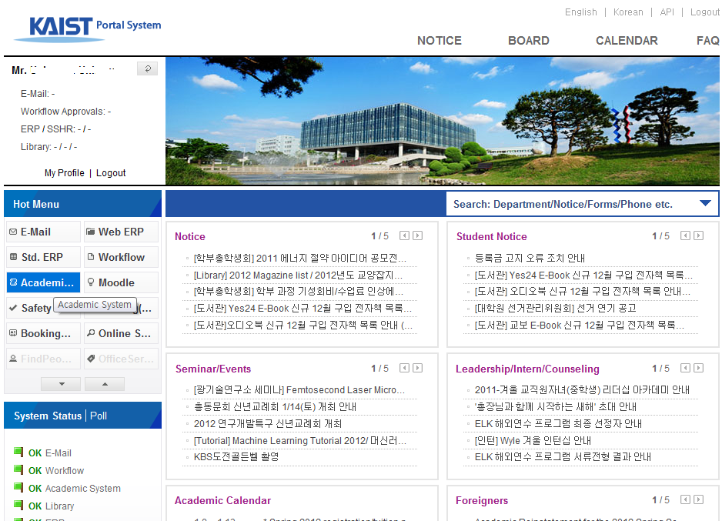
  - When there are a lot of users who are trying to access Academic System, you can see a waiting message box like below. If there are not much users, you can access Academic System without this message box.
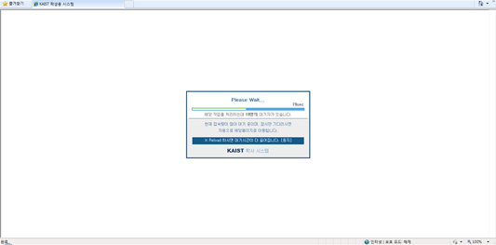

- Select the Add/Drop(half semester) menu
Click Class Enrolment menu and select Add/Drop(half semester) among the sub menus.
When you click it, you will be moved to the Screen to Add/Drop or Withdraw classes and the module will be for the first half semester or the second half semester. The half semester will be selected by the period and deadlines on the Academic Calendar.

- Add/Drop(half semester) Page
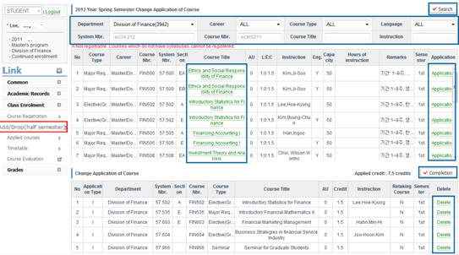
  - The retrieval of Course Descriptions for classes offered
On the Course Registration page, the classes offered by the department of the logged-in user will be retrieved basically. Department is compulsory for retrieval, so it should be selected. Other entry is optional. Enter search criteria and click the [Search] button for retrieval. Because it is the course registration period for first half semester, classes only for the first half semester will be retrieved for adding and deleting classes.
- Career: ALL/Common/Courses for Undergraduates/Courses for graduates (Master’s and doctorate)
- Course Type: Course Type categories (ALL/Mandatory major courses/ Mandatory basic courses/… )
- Language: ALL/English/Korean
- System Nbr.: Course code with 2 or 3 digits
- Course Nbr.: Course code with alphabetic letters and digits
- Course Title: able to search subjects with partial typing of it
- Instruction: the name of professor of the course
  - Retrieval for Syllabuses
If there’s a syllabus for the course, you can see the syllabus with the popup screen by clicking Course Title.
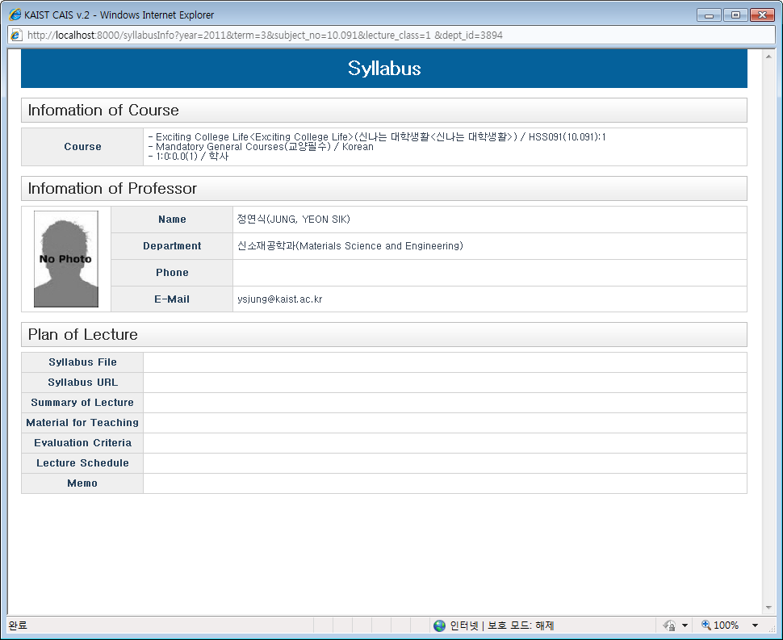
  - Half Semester
    - Half semester courses including First and Second will be presented. The semester will be selected as First or Second according to the period and deadlines on the Academic Calendar.
  - Course Registration
- Application: You can register courses by clicking Application of the course that you want to register. When the registration is completed, you can see the message like below.
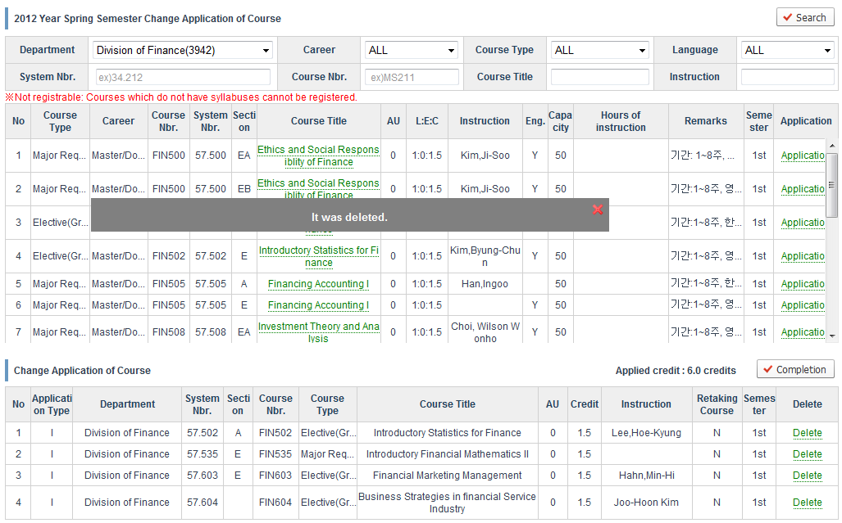
- Not Applicable: When there is no syllabus for a course, you can see Not applicable, and you cannot register this course.
- Input Research Credits: When you register Research (Thesis, Individual) for the Master’s and doctorate courses, input credits and click [Application] button for registration.
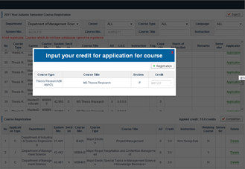
- Registration of retaking courses: When you try to repeat a course, check that it is a retaking course, and click [Retake] button for registration.
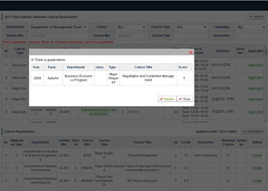
  - Drop Courses
When you want to drop the course that you registered, click Delete at the bottom list for drop it. When the deletion is completed, you can see the message like below.
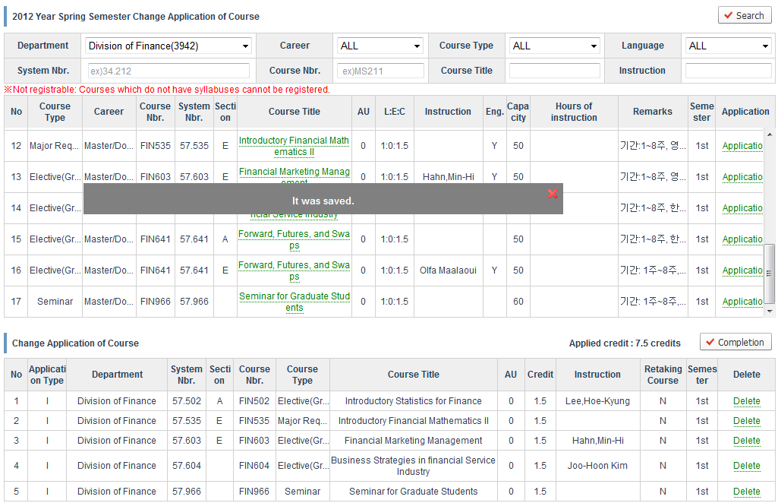
  - Completion of the course registration
When the course registration is completed, you should press [Completion] button for printing out the application for course registration.
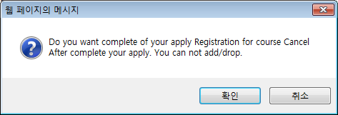
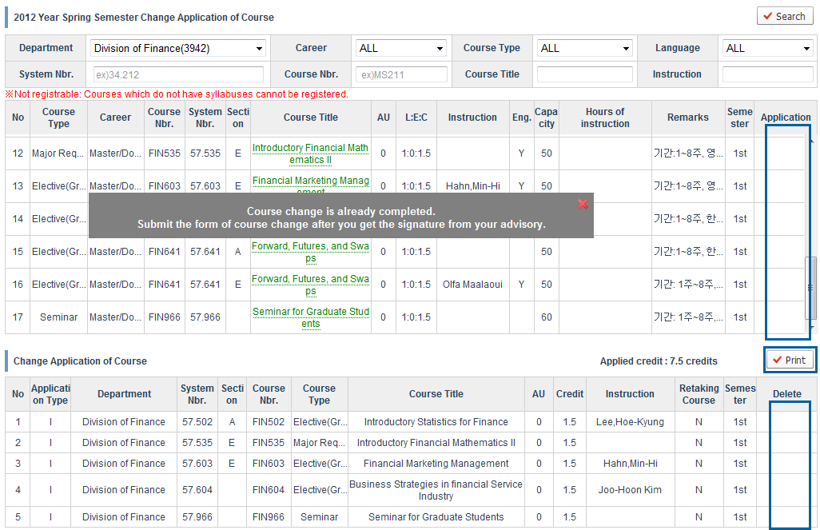
  - Print out Application for Course Registration
When you finish your course registration by pressing [Completion] button, you can see [Print] button, and you can print out your Application for Course Registration. In this status, the [application] and [delete] buttons will disappear and you cannot change your registration record anymore.

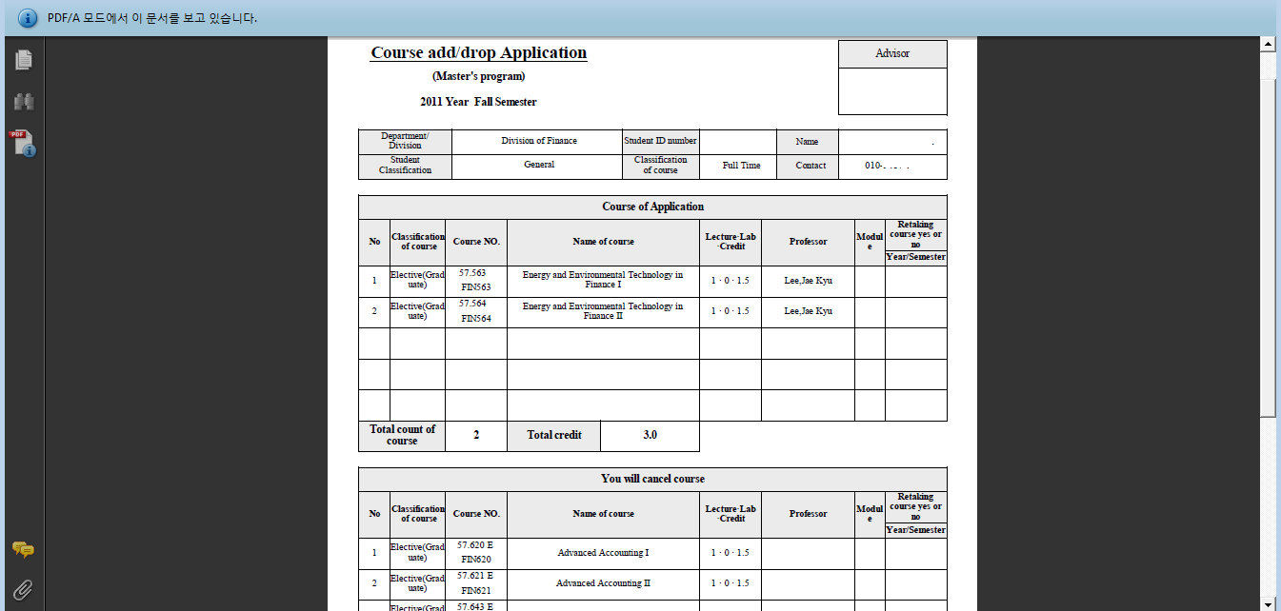

- Course Withdrawal Page
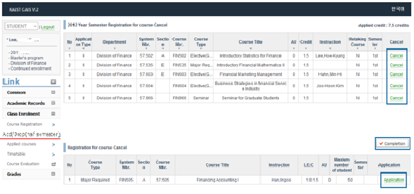

On Add/Drop(half semester) page, the course registration records and withdrawn courses of the logged-in user will be retrieved on upper and lower tables respectively.
  - Course Withdrawal
If you click [Cancel] button, that course will become withdrawn. That withdrawn course will be eliminated from the course registration record and will be added on the withdrawal list.
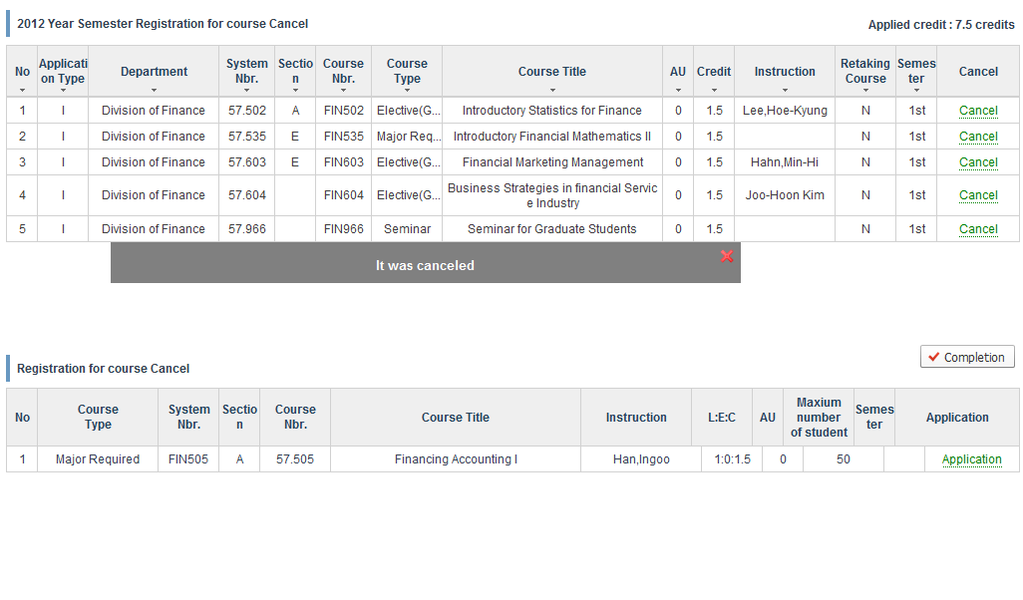
  - Re-enrollment of the withdrawn course
If you click the [Application] button on the withdrawn course list, the withdrawn course will be registered again. That re-enrolled course will be added on course registration record, and will be eliminated from the withdrawn course list.
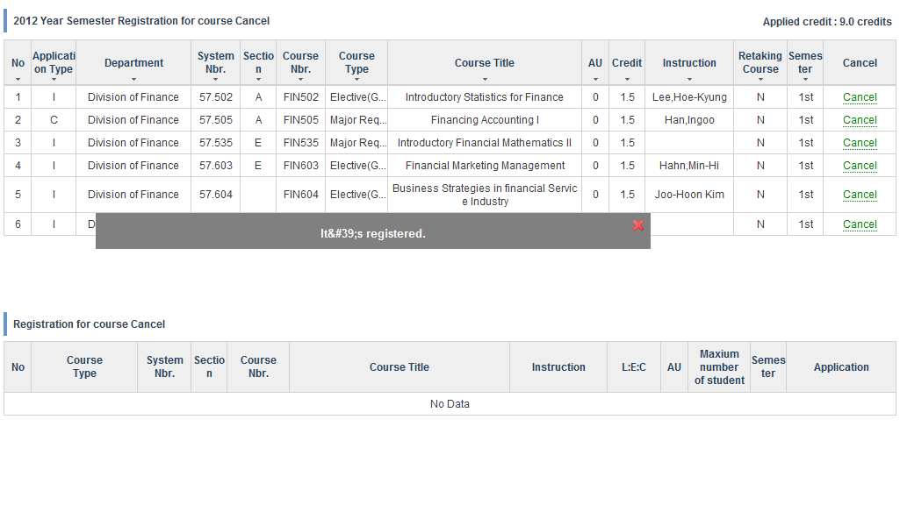
  - Completion of the Course Withdrawal
When you completed course withdrawal, please click [Completion] button to print out the application of course withdrawal.
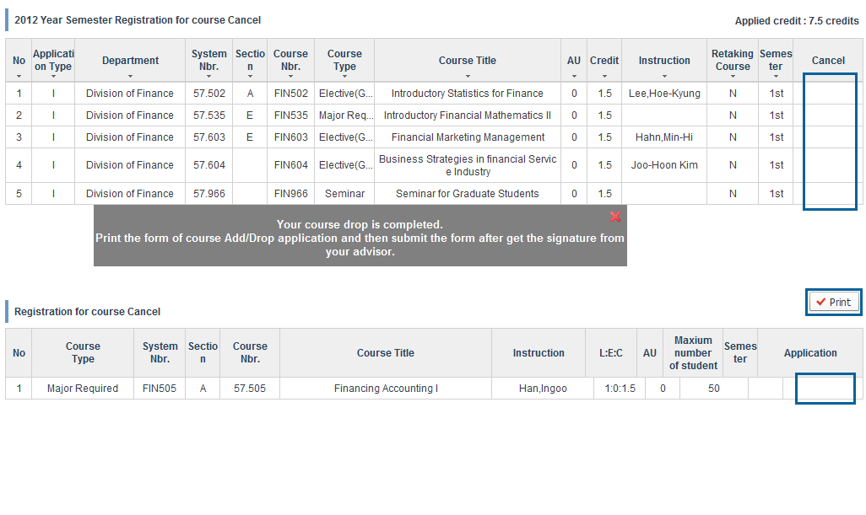
  - Print out the application of the course withdrawal
When you press [Completion] button, it will be changed to [Print] button. Moreover, [Application] and [Cancel] button will be removed. Therefore you cannot register or cancel courses anymore. Please click the [Print] button, and print out the application of the course withdrawal (Course drop Application).


