Academic System User Guide - Student

Table of contents
Access to KAIST Academic System 3
Courses Offered 4
School registration 6
Update Contact 9
Course Registration 11
Applied courses 15
Timetable 17
Mid-Course Evaluation 19
Final Course Evaluation 21
Preview grade 23
Grade Report 25
Application Activity Score 27
Application English Score 29
Apply to submit Korean Score 31
Apply credits at another univ. 33
Apply Credits completed before admission 40
Apply School register change 54
Apply School Records Change 75
Menstrual Leave Requests 77
Course Registration(Exeptions) 79

Access to KAIST Academic System
1. Access to KAIST Academic System
Students will be able to access KAIST Portal System by typing https://portal.kaist.ac.kr on the URL field. After you login to the portal, click the Academic System button from the left menu on the screen.

2. Create portal account
If you do not have a portal account, click the ‘Register’ button to sign up for portal access. To ask questions about registering for an account, inquire by e-mail to: ssoadm@kaist.ac.kr

3. Logout from Academic System
When you click the ‘Close’ link, a popup message will appear prompting you to click ‘OK’ to close the web browser. To logout from the Academic System, click the ‘Logout’ link at the portal.

4. Misc.
- According to the portal SSO policy, the 7789 port must be open on the side of the service requester for the academic system to be connected.
In most environments no problems exist, but some companies may have blocked some outgoing ports (including the 7789 port).
In this event, the user should ask the computer team to open the 7789 port or should use a different PC (e.g., home computer).

Created with the Personal Edition of HelpNDoc: Easily create Web Help sites

Courses Offered
1. Menu

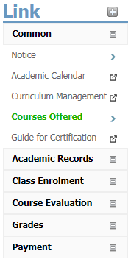

2. Courses Offered
Menu
Common > Courses Offered

※This menu item is accessible to anyone wishing to look up courses offered at KAIST and does not require login

Display
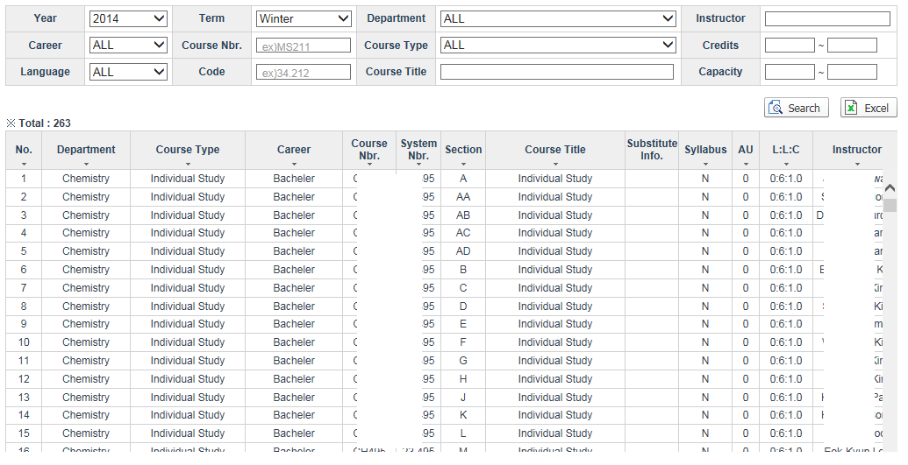
This menu allows you to look up courses offered by semester (Year/Semester)

Searching
- The Year/Term that the course is offered is a mandatory search criterion.
- If you set the search to find ‘All’ courses offered, the search will be very lengthy, as a large amount of data is retrieved and displayed.
- The ‘Limited Class Size’ and ‘Credits’ (AU – academic units) items are retrieved according to results with more than starting value and less than the ending value.
- When an inverted triangle appears under a column header, you can click the [Column Name] to re-sort data according to that column.
- When you click the title of a course, the syllabus will display in a popup window (see [Figure 1] below).
- If the query data exceeds 1000 results, the data will not display on the screen due to excessive time required. Instead, you will be prompted to download directly to an Excel file when you click the ‘Inquiry’ button. Click ‘Confirm’ to download directly to an Excel file
- The Term Type (Module) value ‘16wk' refers to a Seoul 16-Week Course; ‘1st’ and ‘2nd’ refer to Seoul 8-week courses in the first half and second half of the semester, respectively.

Excel Downloads
- You can download the displayed search results to an Excel file by clicking the ‘Excel’ button.

[Figure 1]
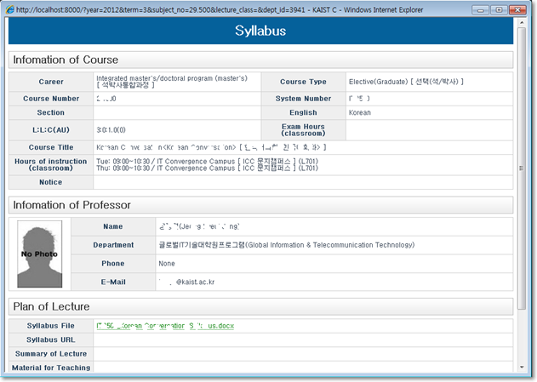

[Tips on Excel downloads]
1. If the blocking pop-up message appears, as shown below, then you should click ‘File Download’ and go through the process again.

2. If the query data exceeds 1000 results, the data will not display on the screen due to excessive time required.
Instead, you will be prompted to download directly to an Excel file when you click the ‘Inquiry’ button. Click ‘Confirm’ to download directly to an Excel file.
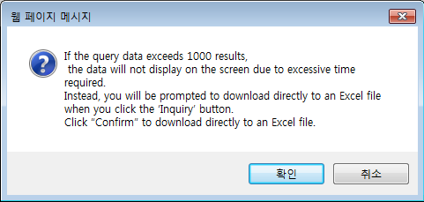

End.
Created with the Personal Edition of HelpNDoc: Easily create iPhone documentation

School registration
1. Menu

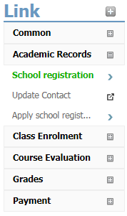

2. School registration

Menu
Academic Records > School registration

Display
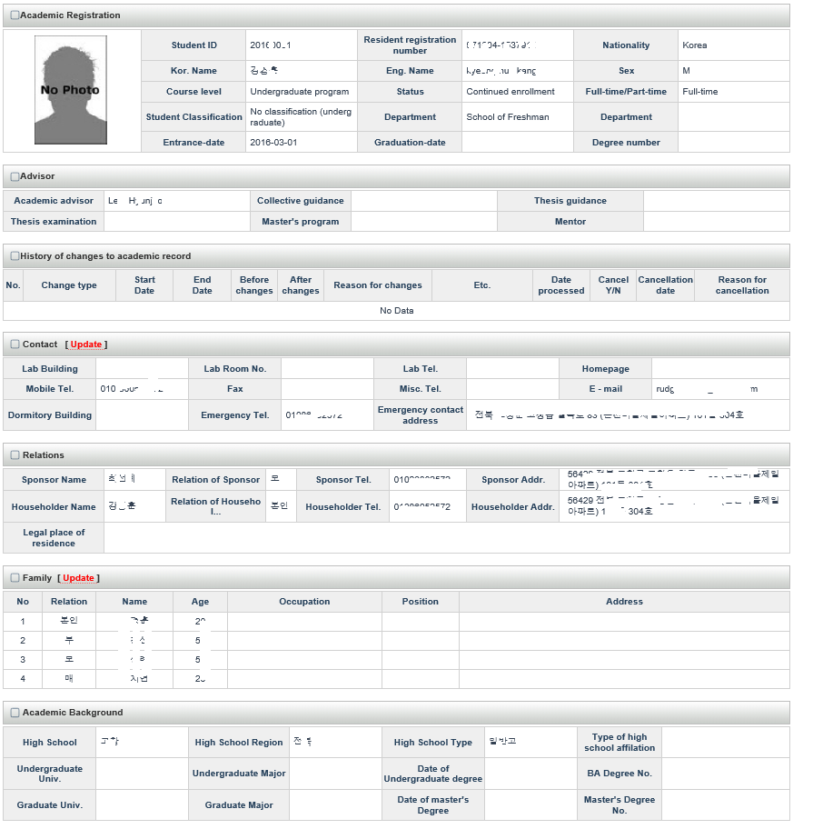
- This menu allows students to look up and check their basic academic information, history of changes to academic record, contact information, sponsor, family, academic background, etc.
- Click the ‘Update/Register contact information’ button and select the [Enter contact information] display to add or change your home address, phone number, mobile number, and e-mail.
(Contact information is used for emergencies and for instructors to send e-mail to students in their courses. The contact information is not used for sending transcripts.)
- if Click the 'update Family information' button, you can update the family information.

[The family information update popup]

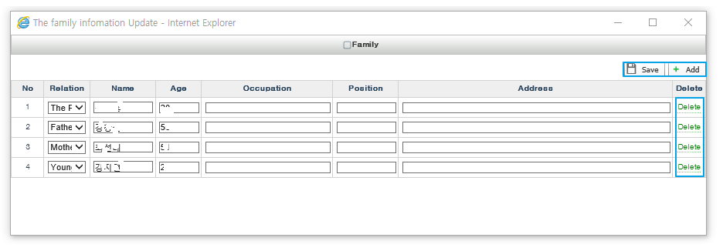
- add: Click the 'Add' button. Required [Relation, Name, Age] items.
- delete: Click the 'delete' link you want to delete.
- save: Click the 'Save' button.

End.
Created with the Personal Edition of HelpNDoc: Easy EPub and documentation editor

Update Contact
1. Menu
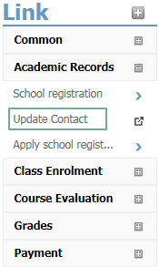

2. Update Contact

Menu
Academic Records > Update Contact

Pop-up Display
When this menu item is clicked, a pop-up window opens allowing you to enter or update your personal address, using the integrated ‘Identity and Access Management Portal Service’ (IAM-PS) as shown below.
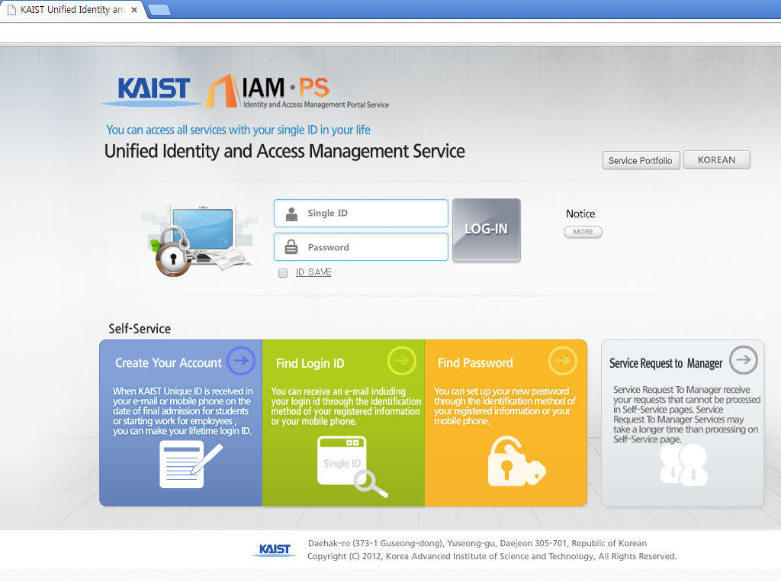
(Contact information is used for emergencies and for instructors to send e-mail to students in their courses. The contact information is not used for sending transcripts.)

End.
Created with the Personal Edition of HelpNDoc: Write EPub books for the iPad

Course Registration
1. Menu
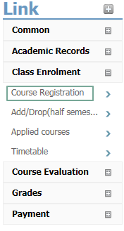

2. Courses Registeration

Menu
Class Enrolment > Courses Registeration

Display
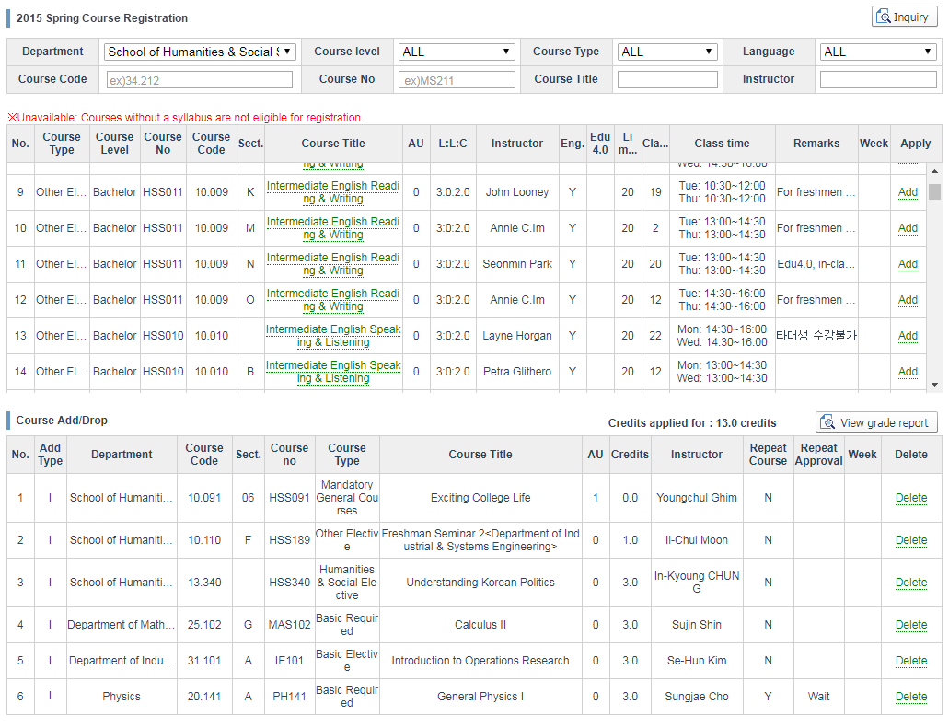
Related Information
- Registration: When registering for courses, only courses with live links are available for registration; courses that are displayed as unavailable for registration are lacking a syllabus.
- GENERAL COURSES: When you click ‘Register’, registration is complete.
- RESEARCH COURSES (GRADUATE LEVEL): When you click ‘Register’, a pop-up window will prompt you to input the course credits. When you input the credits, registration is complete.
- REPEAT COURSES: If you click the ‘Repeat a course’ button on the display showing your prior grade data, then the process of registering to repeat a course is complete.
- When you click the title of a course with a live link, the syllabus will be displayed.
- If you click the ‘Delete’ link for a course you have applied for, the corresponding course will be deleted from your registration history.
- Week: In the College of Business Administration, 16-week courses display as ‘1-16’; 8-week courses in the 1st half of the semester display as ‘1-8’; 8-week courses in the 2nd half of the semester display as ‘9-16’.

3. Changing Registered Courses
Menu
Course registration > Adds/Drops and Withdrawals

※ When Daejeon and Seoul have different academic calendars for the add/drop and withdrawal period,
you should register in accordance with the designated academic calendar for courses in Daejeon and Seoul (16-week; 1st-half; 2nd-half).

※ Registration changes can be made for courses in Daejeon or Seoul (16-week) during the period for adds/drops and withdrawals.

※ To make registration changes for 8-week courses in the 1st or 2nd half of a semester, use the menu path: Course registration > Adds/Drops (half semester).

※ During the period for adds/drops and withdrawals for Seoul 1st-half courses, you can make changes to both 1st-half and 2nd-half courses.
However, during the period for adds/drops and withdrawals for Seoul 2nd-half courses, changes may only be made to 2nd-half courses.

Display
- The display is the same as for adds/drops and withdrawals.

4. Withdrawing from a Course

Menu
Course registration > Adds/Drops and Withdrawals

※ During this period, you can withdraw from courses you have registered for in Daejeon and Seoul (16-week).

※ To make registration changes for 8-week courses in the 1st or 2nd half of a semester, use the menu path: Course registration > Adds/Drops (half semester).

※ During the period for adds/drops and withdrawals for Seoul 1st-half courses, you can make changes to both 1st-half and 2nd-half courses.
However, during the period for adds/drops and withdrawals for Seoul 2nd-half courses, changes may only be made to 2nd-half courses.

Display
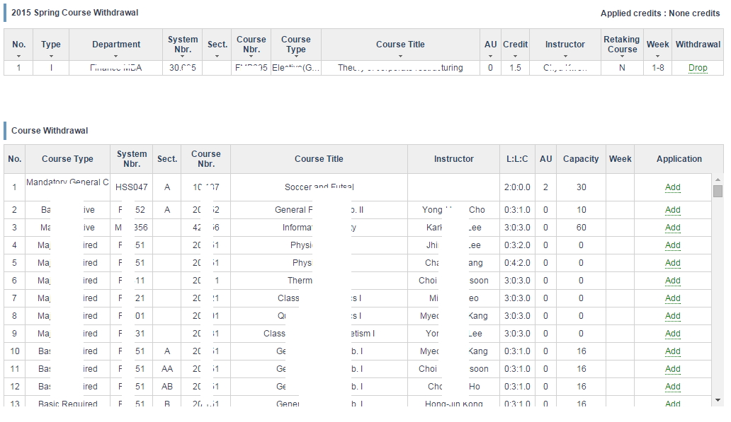
5. Tips
- You can use the Personal Timetable Menu to view your timetable of registered courses (color coding is as follows: Daejeon /Business Administration 16-week: BLACK; 1st-half 8-week: RED; 2nd-half 8-week: BLUE).
- The Adds/Drops (half semester) menu is for students wishing to take only courses that a department is offering separately in the first half (weeks 1-8) or second half (weeks 9-16) of a semester.
- Registering System is opened from 12:30(lunch time) of starting day to 23:59 of ending day.

6. 'Please wait' Window
- If too many users are connected at once to the course registration system, then users must wait for permission to access the system.
Each user will receive a computerized ticket number and can view a status window indicating the user’s place in the waiting order.
As the number of users waiting and the wait time decreases, your service order will automatically advance to the next page. (Note that if you press the Refresh button, you will start over with a new number ticket and must once again wait for your turn.)
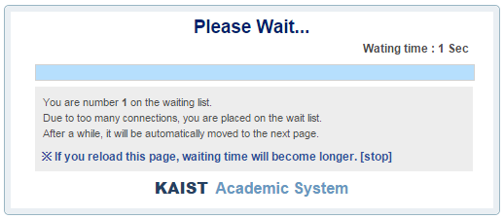
7. computerized Lottery for Registration
- A computerized lottery is implemented in the first registration period for the spring, summer, fall and winter semesters (four times a year).
- The computerized lottery is implemented for courses in the spring and fall semesters which limit the number of students to a maximum class size. After unrestricted registration on the first day, the computer system will conduct a random drawing on the second day for courses where the number of registrants exceeds the maximum class size.
- Registration System Hours
First Day: (12:30 - 23:59)
Second Day: Registration suspended
Third Day: (reopens at 12:30)
Final Day: (closes at 23:59)
- Course registration records for students not selected during the lottery drawing will be deleted.
- Student selected in the lottery drawing cannot delete the course, and must wait until the period for adds/drops and withdrawals if they wish to delete it.

8. Course Retake Application
- Online application may be submitted up to three days (working days) prior to the end of the course add/drop period
- Course professor shall provide approval online for course retake applications; unapproved applications up to three days (working days) before the end of the course add/drop period shall be automatically cancelled
- Course registration shall be immediately cancelled if the course retake application is rejected by the course professor; Re-applications can be submitted using the paper form

End.
Created with the Personal Edition of HelpNDoc: Full featured EPub generator

Applied courses
1. Menu
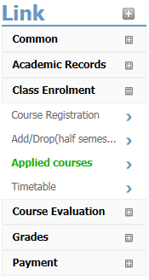

2. Look Up Registered Courses
Menu
Class Enrolment > Applied courses

Display
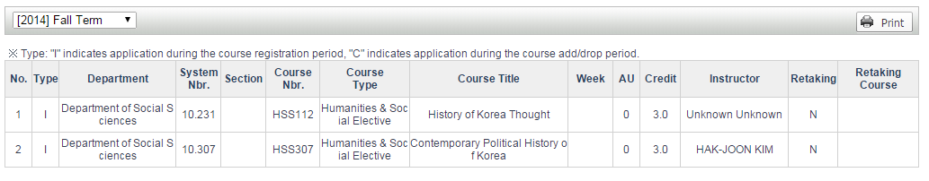
- You can view your history of registered courses by Year/Semester.
- The codes for “Registration Type” are as follows: ‘I‘ refers to courses registered for during the regular registration period; ’C‘ refers to courses registered for during the add/drop period.

[Print Display for Application report]
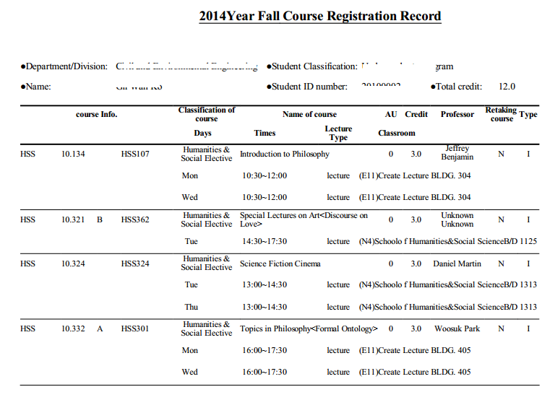
※ When displaying the document, if you see a blank screen or the screen indicates a pdf problem, you should update Acrobat Reader to the latest version.
(Contact: IT Development Team (e-mail: acad@kaist.ac.kr / ext. 2132)

End.
Created with the Personal Edition of HelpNDoc: Full featured Documentation generator

Timetable
1. Menu
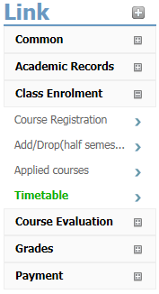

2. Personal Timetable
Menu
Class Enrolment > Personal timetable

Display

- You can view a timetable of your registered courses.
- If there are duplications or conflicts in the class times for registered courses, then a message will display alerting you to the conflict: ‘This class time conflicts with the 'xxx' course.’
- Seoul Campus 8-week courses are color-coded as follows: 1st-half courses are RED and 2nd-half courses are BLUE.
Note that 1st-half and 2nd-half courses do not affect each other in terms of time conflicts.
- NOTE: This menu item does not have a print function of its own. To print it, use the browser print function or create a screen capture.

End.
Created with the Personal Edition of HelpNDoc: Full featured Help generator

Mid-Course Evaluation
1. Menu
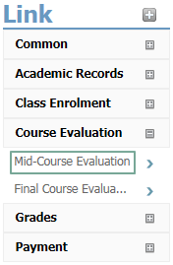

2. Mid-semester Course Evaluations
Menu
Course Evaluation > Mid-Course evaluation

Display
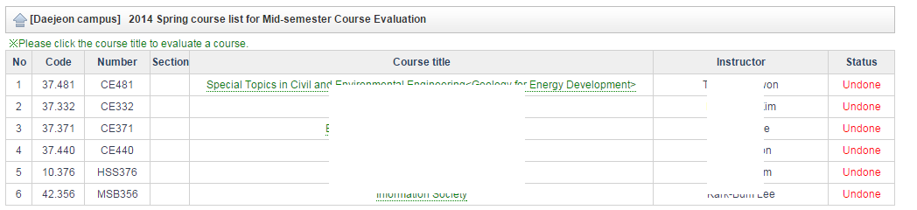
Related Information
- If it is not the period for mid-semester course evaluations, a message will display that information.
- When you click the title of the course you are evaluating, an evaluation window will open.
- Confirm that the status has changed from ‘To be done’ to ‘Done’ upon completion.
- After initially completing the evaluation, you may keep returning to it again to make changes.

Evaluation Display
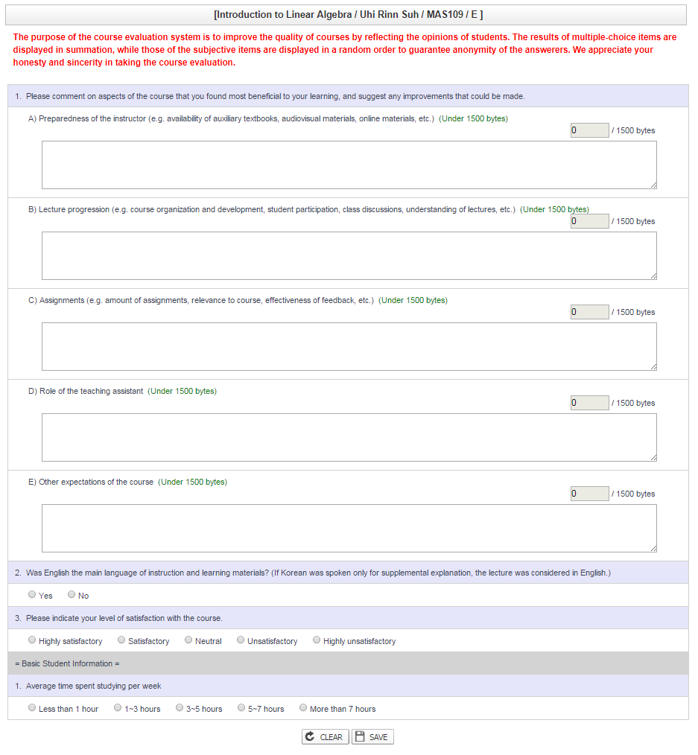
Related Information
- Responses to the 5 items in the questionnaire must be limited to 1500 bytes (750 Korean characters, 1500 English characters). Excess characters are automatically deleted.
- The number of bytes already used is displayed in a small box at the upper right section of the display.
- All fields are required to be completed. If you click ‘Save’ before filling in all the fields, the system will not save the fields but instead a popup will prompt you to complete the specified missing field(s).
After entering your response(s) in the corresponding field(s), click ‘Save’ again.
- You can use the ‘Initialize’ button to restart the evaluation, deleting all of your content so you can enter new content.

End.
Created with the Personal Edition of HelpNDoc: Free EPub and documentation generator

Final Course Evaluation
1. Menu
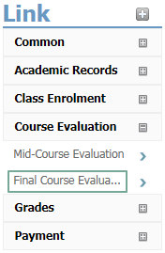

2. Final Course Evaluation
Menu
Course Evaluation > Final course evaluation

Display
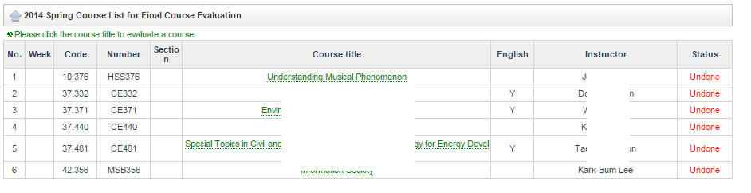
Related Information
- If it is not the period for course evaluations, a message will display that information.
- When you click the title of the course you are evaluating, an evaluation window will open.
- Confirm that the status has changed from ‘To be done’ to ‘Done’ upon completion.
- After initially completing the evaluation, you may keep returning to it again to make changes.
- Week: blank (Daejeon campus), 1-16 (Seoul campus 16-week course), 1-8 (Seoul campus 1st-half course), 9-16 (Seoul campus 2nd-half course)

Display for course Evaluation
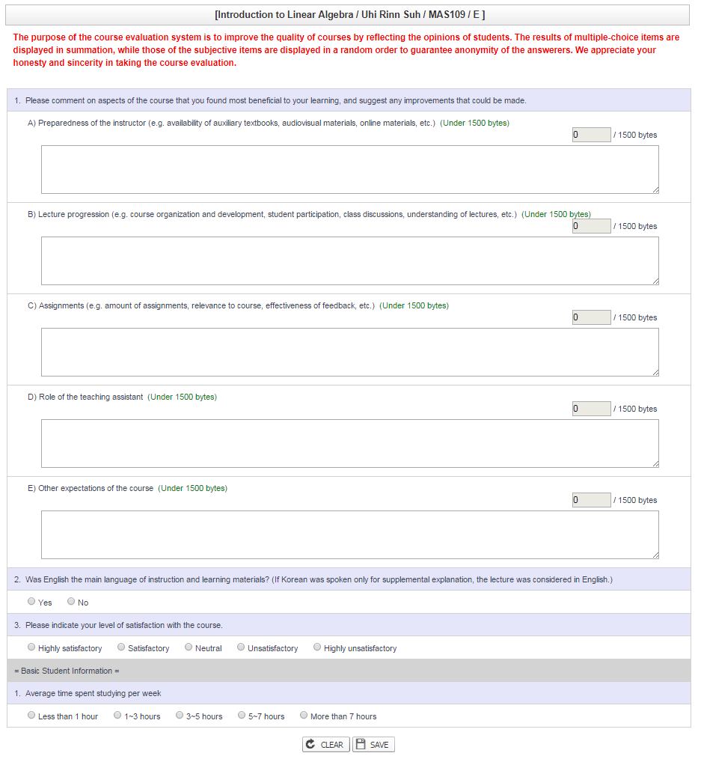
Related Information
- Structure, Intelligibility, Atmosphere, Contribution, and English are all required fields.
- If you click ‘Save’ before filling in all of the required fields, then the system will not store the fields but instead a popup will prompt you to complete the specified missing field(s). After entering your response(s) in the corresponding field(s), click ‘Save’ again.
- You can use the ‘Initialize’ button to restart the evaluation, deleting all of your content so you can enter new content.

English Questionaire (for non-English instruction)
- If the course instruction is not designated to be in English, this item will automatically be set to ‘No’ and cannot be changed.

End.
Created with the Personal Edition of HelpNDoc: Easily create HTML Help documents

Preview grade
1. Menu
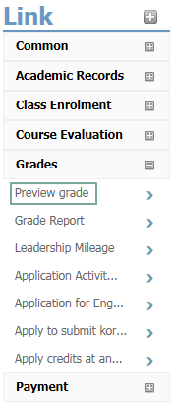

2. Previewing Posted Grades
Menu
Grades > Preview grade

Display indicating it is not the grade posting period
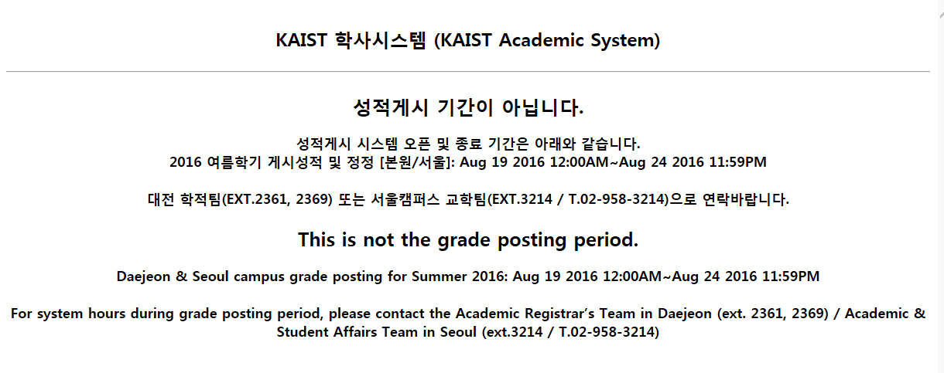
- This menu allows you to preview posted grades during the grade posting period; if it is not the grade posting period, a message will display that information as shown above.

Display for previewing posted grades
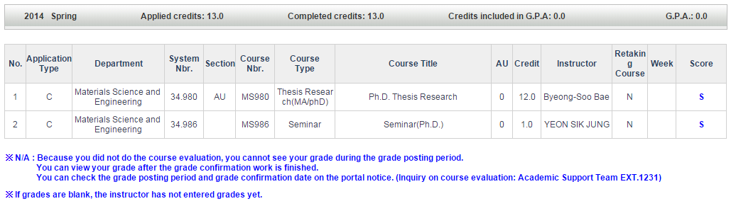

- This menu allows you to preview the grade posted by the instructor during the grade posting period. This grade has not yet been finalized or transferred to your official transcript.
- If the grade column is marked ‘N’(“Not Ready”), you cannot check your grade until it has been transferred to the relevant department because you have not submitted a course evaluation.
- If the grade column is blank, the instructor has not yet entered a grade contact the instructor.

End.
Created with the Personal Edition of HelpNDoc: Easily create CHM Help documents

Grade Report
1. Menu
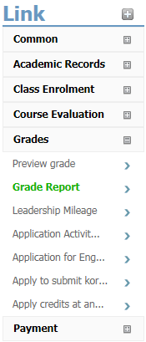

2. Viewing Grade Reprots
Menu
Grades > Grade Report

English Scores
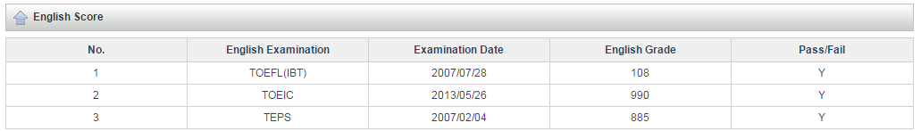

- You can view the history of your scores for standardized English tests, such as TOEIC, TOEFL, TEPS, etc.

Essay Grades
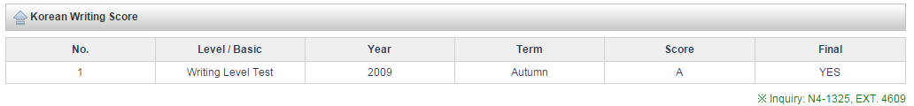
- You can view your grade for the Essay Level Test.

Grade Report for All Courses
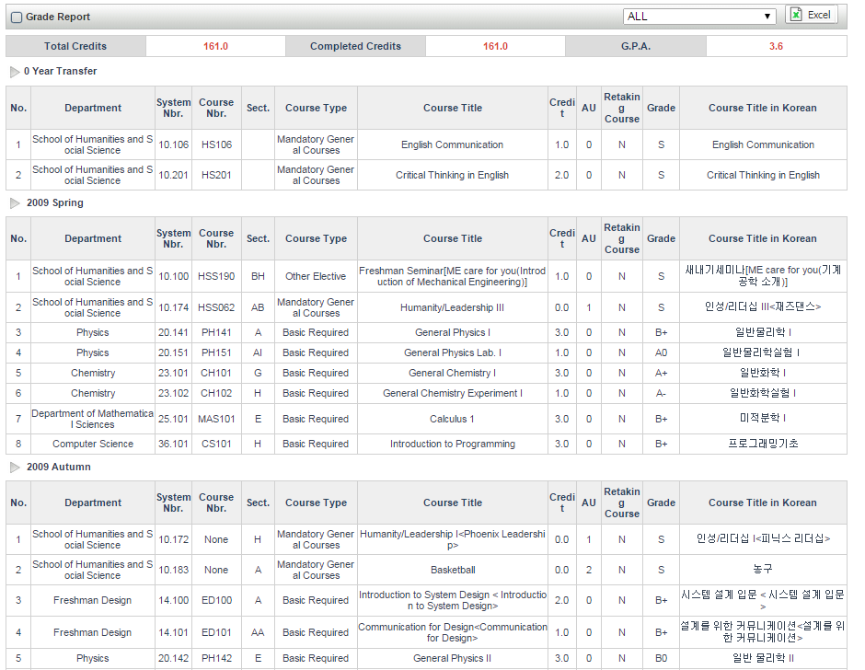
- You can view grades from courses completed at other universities, courses completed at KAIST, and grades by Year/Term/Course.
- If you select “All terms”, you can view registered credits, completed credits, and average credits.
And if you select a particular fixed Year/Term, the system displays the registered credits, completed credits, and average credits of the corresponding term.
- You can download the retrieved history to an Excel file by clicking the ‘Excel’ button.
- If the grade column contains the code ‘I’, this means that the grade has not yet been input and you should contact the instructor.

End.
Created with the Personal Edition of HelpNDoc: Free PDF documentation generator

Application Activity Score
1. Menu

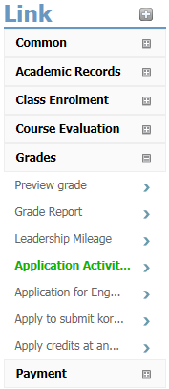

2. History of community Service Applied for
Menu
Grades > Application Activity Score

History of community Service
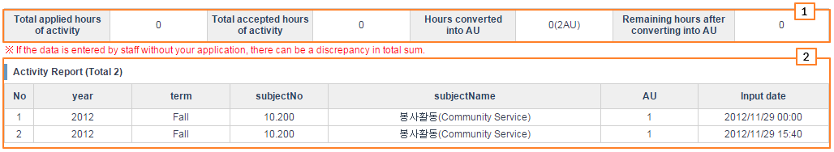
Point 1 – Print all community service by student
TOTAL HOURS APPLIED FOR: Total hours of community service applied for by student
TOTAL HOURS APPROVED: Total hours of community service recognized by the official in charge of the service agency
Point 2 - Hours converted into AU (credits)

History of community service applied for and new entries
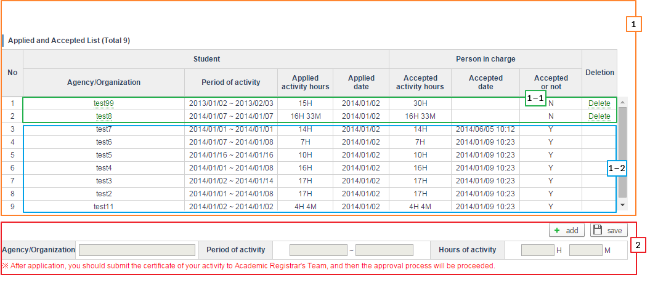
Point 1 – Print community service activities applied for and information on approved activities.
Point 1-1 – Community service activities not approved by the official in charge of service
※ You can change and delete these entries by clicking the organization activity.
Point 1-2 – Community service activities approved by the official in charge of service
※ Community service activities which have been approved cannot be changed or deleted.
Point 2 – You can update your community service activities and enter new activities.
※ To enter new community service activities, click the [New] button to activate the input window.
The [Agency/Organization] and [Period of activity] are mandatory columns and the [Hours of activity applied for] is saved when you have entered the hours and minutes.

※ When you apply for a new community service activity, you must submit certification of your activity to the Academic Registrar's Team to start the approval process.

End.
Created with the Personal Edition of HelpNDoc: Free EPub and documentation generator

Application English Score
1. Menu
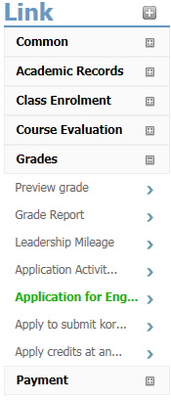

2. Submitting English scores

Menu
Grades > Application English Score

History of English scores submitted & new or changed entries
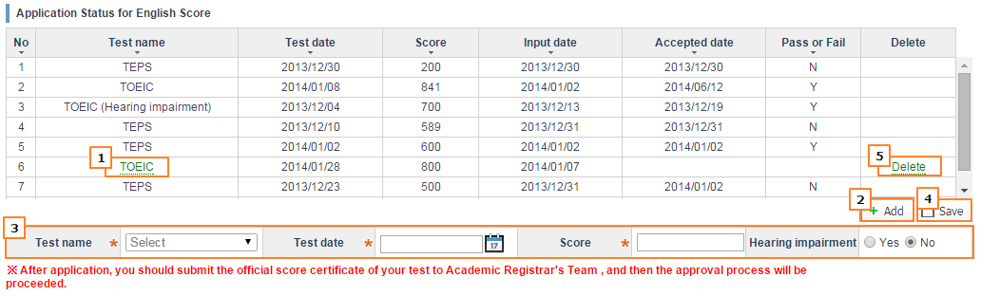
[Applying]
Point 2 - When you click ’New‘, a new input record is activated.
Point 3 – Input all required fields.
Point 4 – Click ’Save‘ and your application is complete.

[ Change ]
Point 1 - After an English score has been approved, a live link will not be displayed.
If you click an examination which is still not approved, then the computer system will show the information below the fields.
Point 4 - If you have changed the information you wished to modify and then click ‘Save’, the information in your application will be changed.

[ Delete ]
Point 5 - If you click the ‘Delete’ button for an item on a list of tests which have not yet been approved, the requested PICPICKSHAPErecord will be deleted.

Criteria for Passing Scores for English Proficiency
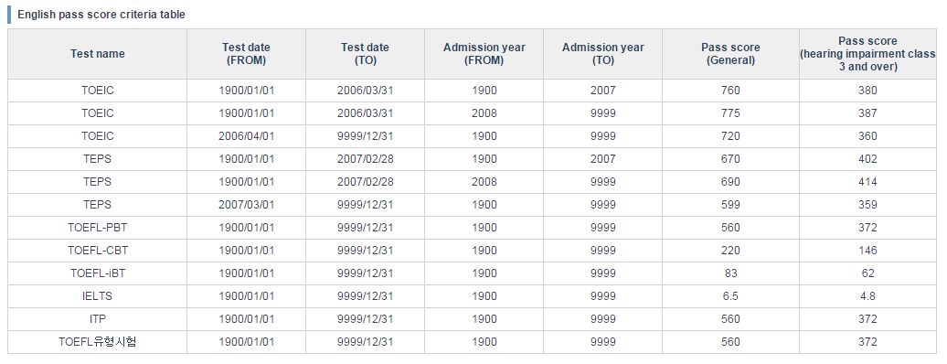
You can view the criteria for scores deemed adequate to demonstrate English proficiency.

※ You must submit a transcript of your English examination to the Academic Registrar's Team to start the approval process.

End.
Created with the Personal Edition of HelpNDoc: Easy to use tool to create HTML Help files and Help web sites

Apply to submit Korean Score
1. Menu
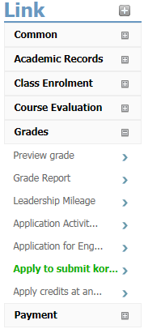

2. Apply to submit Korean Score

Menu
Grades > Apply to submit Korean score

History of Korean scores submitted & new or changed entries
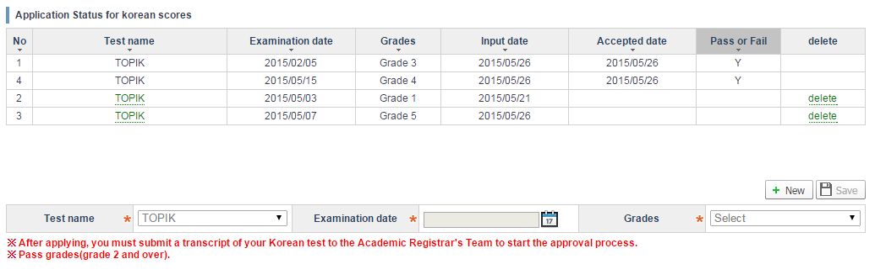
After an korean score has been approved, Pass or Fail contents will be displayed and a live link will not be displayed.
If examination is still not approved, you can modify and delete an korean score.

Display indicating it is no foreigners in the undergraduate who have enrolled since 2013.

End.
Created with the Personal Edition of HelpNDoc: Easy EPub and documentation editor

Apply credits at another univ.

1. Purpose and Background of Apply credits at another univ.
You can apply for approval of credits you obtained at another university through the system.

2. Menu
Grades > Apply credits at another univ.

3. authority
- All students.

4. Display and Explanation

Search
[Screen shot of search conditions]
- If you change the type of status change you are applying for, the user interface (UI) will be changed to the relevant form.

Educational status at other university
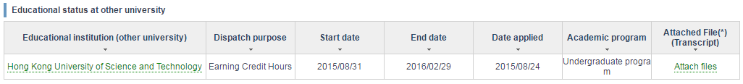[Screen shot of a current educational status at an educational institution (other university)]

Registering an educational institution (other university)
- Dispatch without a leave of absence: Apply for Registration Status Change -> Apply for Dispatch without Leave of Absence (Details on type of status change: Earning Credit Hours-Abroad, Dual degree-Abroad).
- Completed before admission: Apply for Approval of Credits Obtained at other University -> If you click the “Register Educational Institution (other University)”, a pop-up screen for registering an educational institution will be created.
- Credits obtained during a vacation or leave of absence period: Apply for Approval of Credits Obtained at other University -> If you click the “Register Educational Institution (other University)”, a pop-up screen for registering an educational institution will be created.
- Exchange program (university specializing in science & technology): Apply for Registration Status Change -> Apply for Dispatch without Leave of Absence (Details on type of status change: Earning Credit Hours-Domestic)

Educational institution (other university)
- If you click the Institution Name link, a list of the “current status of application for credits (approval form for equivalent courses)” will be searched for and displayed, and you can apply for credit approval.
- If the educational institution (other university) you are seeking does not appear, please contact the Academic Registrar's Team.

Attached File(Transcript)
- If you click this link, a pop-up screen for managing attached files will be created.

Modifying/deleting the educational institution (other university) (Completed before admission, Credits Obtained during Vacation or Leave of Absence Period)
- If you click the Modify link, a pop-up screen will be created and you can modify the institution information.
- If you click the Delete link, the institution information will be deleted.
- If you are applying for credit approval, you cannot modify/delete the relevant institution information.

Management of the attached file (grade transcript)
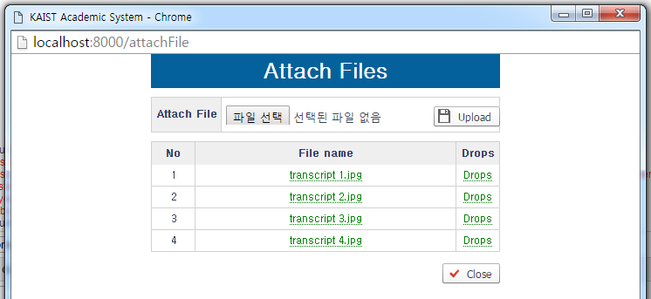[Screen for managing the attached files]
How to upload a transcript
1. Click the “Choose File” button under “Attached Files”.
2. Choose the file you want to upload.
3. Click the “Upload” button.
When the file is uploaded, it will be added to the list.
Download
- If you click the File Name link, the relevant file will be downloaded.
Deletion
- If you click the Delete link, the relevant file will be deleted.
※ You can attach a grade transcript only in the form of an image file (jpg, png, gif, tif).
※ You can attach only 2MByte or smaller files.
※ If there is an application for credit approval which has been approved/returned by a professor, you cannot upload or delete any files.
※ If the application period has passed, you cannot upload or delete any files.
※ You can apply for credit approval only after attaching a grade transcript.
※ You must submit one original copy of the attached transcript to the Academic Registrar's Team.

Registering and modifying an educational institution (other university)
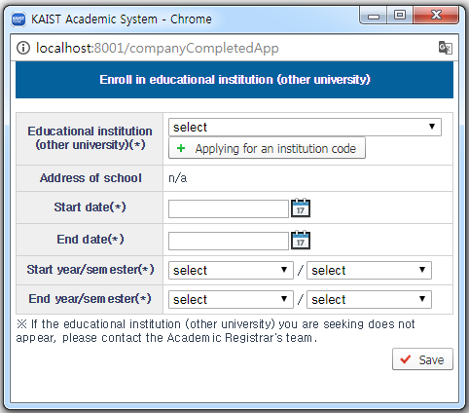[Screen for registering an educational institution (other university)]

Registration
- If you enter/choose all the items and click the Save button, the educational institution information will be registered.
- Once the educational institution information has been registered, the pop-up screen will automatically close and the current educational status of the educational institution (other university) will be searched for and displayed.

Modification
- You can modify only these items: “Start date”, “End date”, “Start year/semester”, or “End year/semester”. If you modify any of these items and click the Save button, the educational institution information will be modified.
- Once the educational institution information has been registered, the pop-up screen will automatically close and the current educational status of the educational institution (other university) will be searched for and displayed.

How to apply for an institution code
1. Click the “Apply for Institution Code” button.
2. Click the “New” button on the newly created pop-up screen.
3. After entering the institution information, click the “Apply (Save)” button.
※ If there is no institution information in the option for choosing an educational institution (other university), apply for an institution code.
※ Once the institution code applied for has been approved, the relevant institution information will be added to the option for choosing an educational institution (other university).
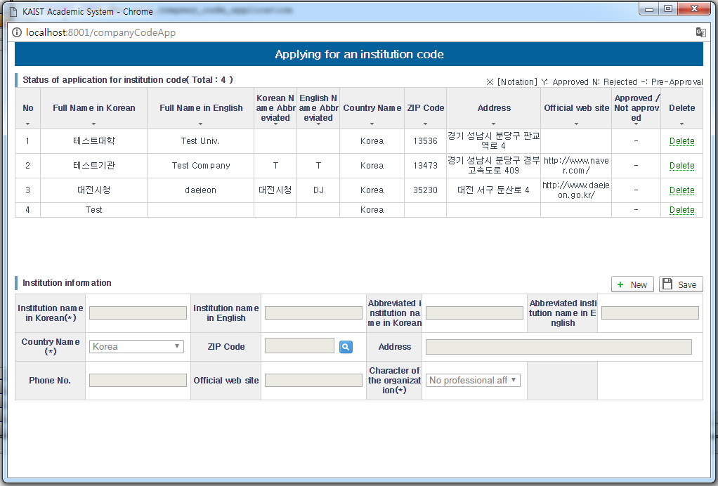[Screen for applying for an institution code]

Status of application for credit approval(Course equivalency table)
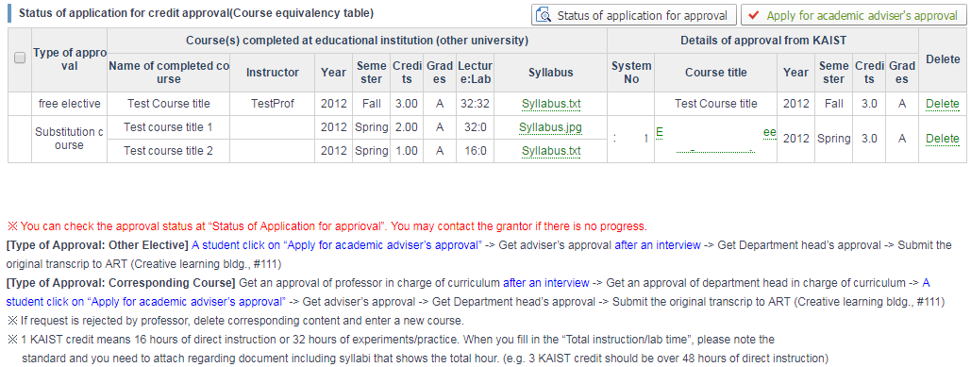[Screen for a current status of application for credit approval (course equivalency table)]
Checkbox
- Once both prior confirmation of the filed application and approval thereof by the department office and the course-related professors have been completed, a checkbox will be created.

Syllabus download
- If you click the Syllabus File Name link, the relevant file will be downloaded.

Delete
- If you click the Delete link, the details of the application for credit approval will be deleted.

Status of application for approval
- If you click the Status of Application for Approval button, a pop-up screen will be created and both the information on the person in charge of approval and the information on the current status of approval progress will be searched for and displayed.

Application for academic adviser's approval
- If you check the application details that you want to submit to your advising professor for approval and then click the button, the application for approval will be completed.
※ Please apply to your advising professor for approval after checking all the items in the application.

Status of application for approval
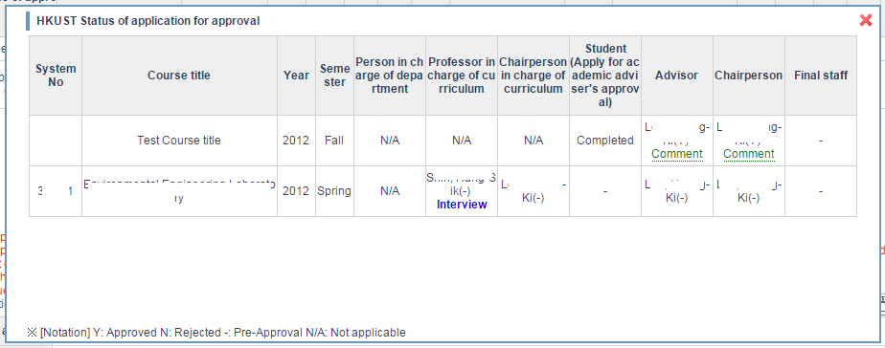[Screen for a current status of application for approval]
- During the approval process, the phrase “Interview” is indicated in the information on the professor who regards it necessary to have a personal meeting with the student.
- If the application for approval has been approved/returned after the professor’s opinion is entered, the “Comment” link will be indicated. In this case, if you click the link, the content of the professor’s opinion will be searched for and displayed.

Register/Change - Other Elective / Elective
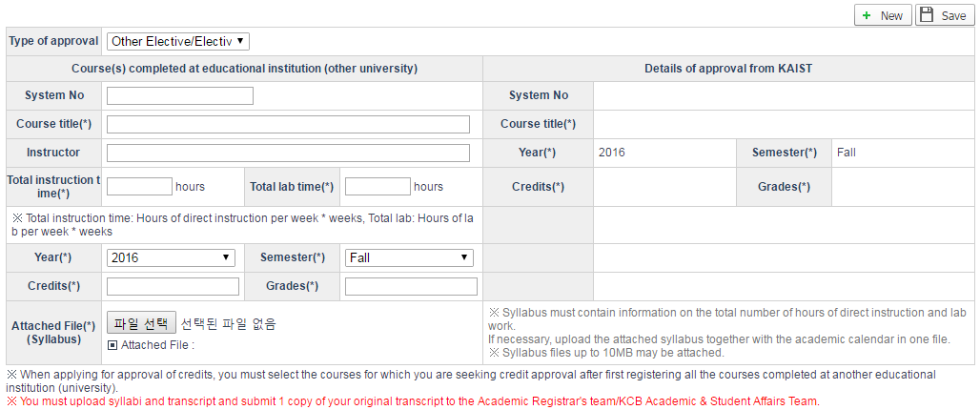[Screen for choosing items freely/entering chosen items]
How to apply for credit approval
1. Click the New button.
2. Enter/choose all the required items (*).
3. Choose the Syllabus file you want to upload.
4. Click the Save button.
※ If you apply for approval of the credits you obtained during your vacation/leave of absence, a mail requesting approval will be sent to the person in charge of prior confirmation of the application.
※ If you enter the information on the course you completed at an educational institution (other university), the contents approved by KAIST will be automatically entered.

Register/Change - Corresponding course
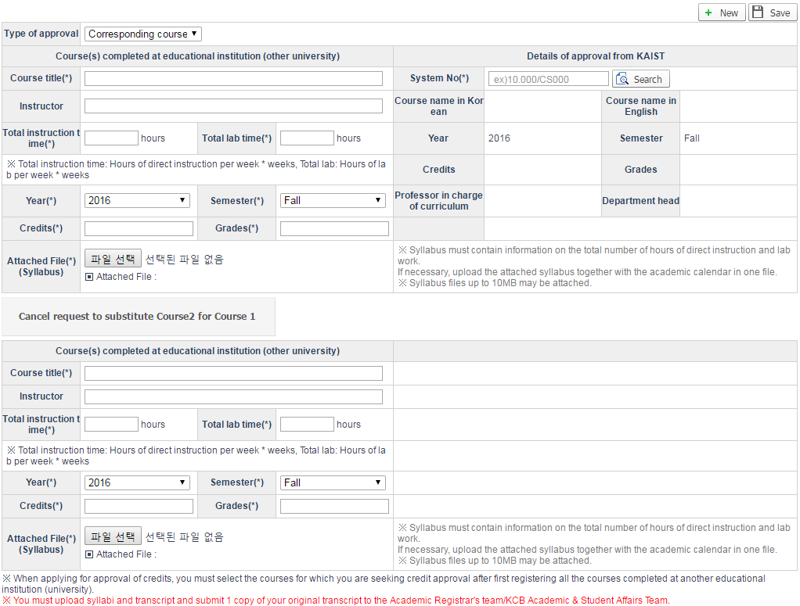[Screen for entering the corresponding course]

How to apply for credit approval
1. Click the New button.
2. Enter/choose/look up all the required items (*) and then make a choice.
3. Choose the Syllabus file you want to upload.
4. Click the Save button.
※ If you apply for approval of the credits you obtained while being dispatched without taking a leave of absence or before admission, a mail requesting approval will be sent to the professor in charge of the relevant course.
※ If you apply for approval of the credits you obtained during your vacation/leave of absence or the credits you obtained as an exchange student at a specialized university, a mail requesting approval will be sent to the person in charge of prior confirmation of the application.

If you click the “Request to substitute Course2 for Course 1” button, an additional entry field for entering the information on any completed course will be created.
If you click the “Cancel request to substitute Course2 for Course 1” button, the additional entry field will be removed.

[How to choose a completed course]
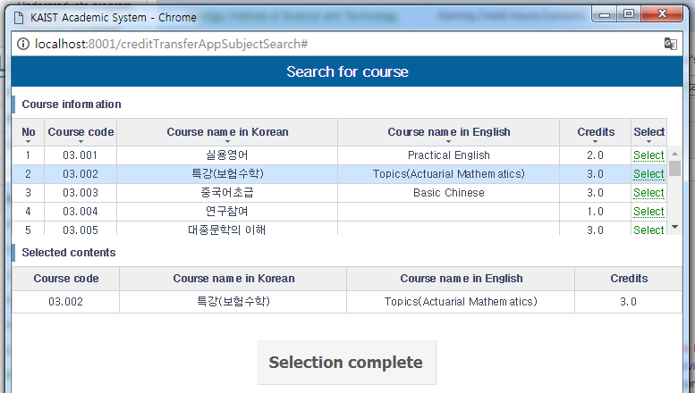[Pop-up screen for choosing the information on a course completed at an educational institution (other university)]
1. Click the Search button under the computer code item for a course completed at an educational institution (other university).
- If you click the Search button, a pop-up screen for choosing the information on the courses by educational institution will be created.
※ If there is no information on the course you have taken on the course list, please contact the Academic Registrar's Team.
2. Choose a course.
3. After confirming the details of the chosen course, click the Complete button.
- The information on the chosen course will be automatically set in the entry field for the course completed at the educational institution (other university) and the pop-up screen will be closed.

[ How to select corresponding course info.]
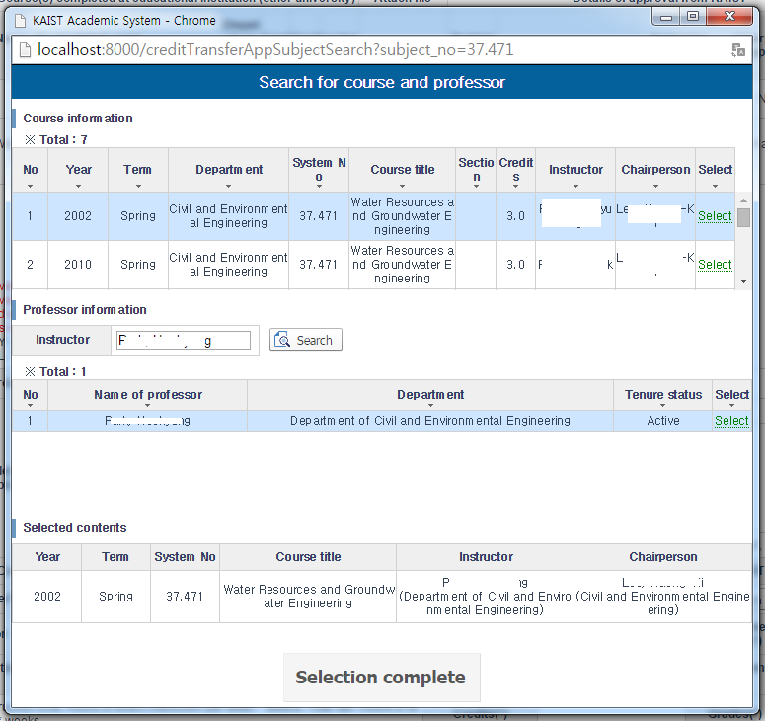[Pop-up screen for choosing the information on a KAIST approved course]
1. Enter the computer code item for the course details approved by KAIST and then click the Search button.
- If you click the Search button, a pop-up screen with a list of courses searched for will appear.
2. Confirm the professor in charge of the course you want to get approved for among the list and then click the Choose link.
3. If you choose a course, the information on the professor in charge of the course will be automatically searched for/selected.
4. If you confirm the details of the chosen course and then click the Complete button, the chosen course details will be set in the entry field for the course details approved by KAIST.
※ You can choose only an incumbent professor for such purpose. If you cannot choose a professor right now, please look up professors from whom you want to obtain approval yourself and then choose a professor.

End.
Created with the Personal Edition of HelpNDoc: Free Web Help generator

Apply Credits completed before admission

1. Purpose and Background of Apply credits completed before admission
Apply for Joint Advanced Placement Program, Individual Advanced Placement Program, mutually recognized/cross-registration course/Honor, Bridge Program, audited, credits transfer to another department, PhD candidates who have changed departments,
and credits previously completed at KAIST through the system.

2. Menu
Grades > Apply Credits Completed Before Admission

3. authority
- All students

4. Display and Explanation

Search
- You can see the list of course credits you have applied for transfer when you select the type of credits completed before admission.

Courses applied
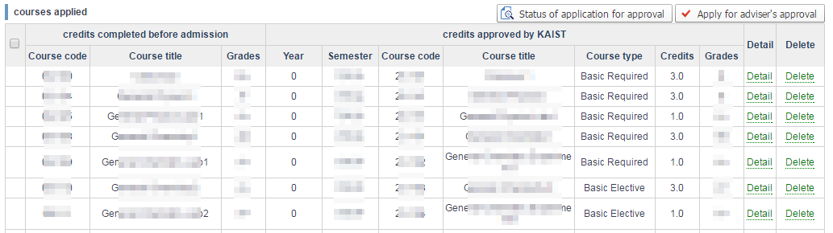
- Check-box
. After completing all the courses, click the "Apply for advisor's approval" button and an approval request will be sent to the advisor.
※ When applying for approval to the next person in charge, apply for all the course at the same time.
- Detail Link
. Click link to view details on course titles.
- Delete Link
. Click link to delete courses you have applied to have credits transfer.
. When you delete the course, a cancellation email will be sent out to the current person in charge of the process.
. You can delete a request at any time until the final staff’s approval has been made.
- You can check the status on a pop-up screen by clicking "Status of application for approval".
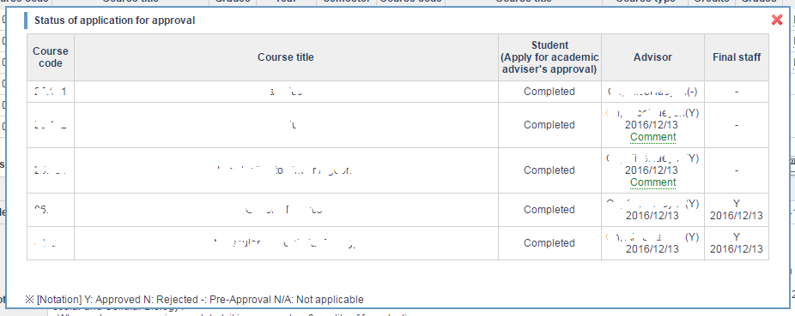
. If a person in charge enters the content of a meeting regarding approval/return, an opinion link gets created.
. When you click the "Comment" link, you can see the content of the meeting.
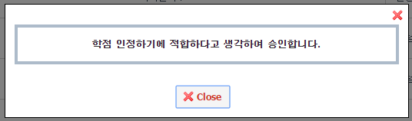

Register and Modify
1. Joint Advanced Placement Program
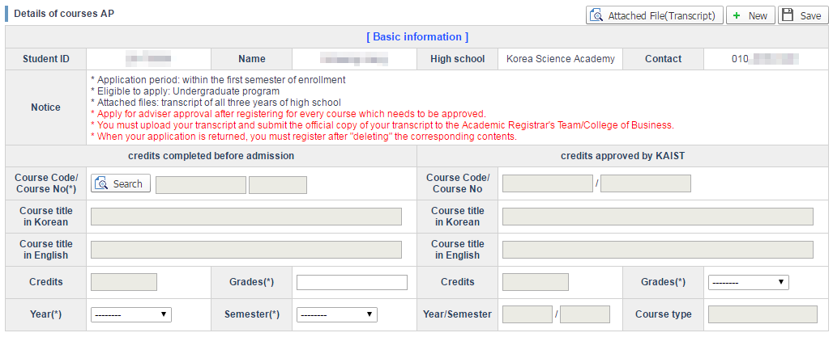
※ For AP, you must upload your transcript to apply for credit approval.

How to Register
1. Upload your transcript.
. Click the "Attach File(Transcript)" button and a pop-up screen as shown below will be created.
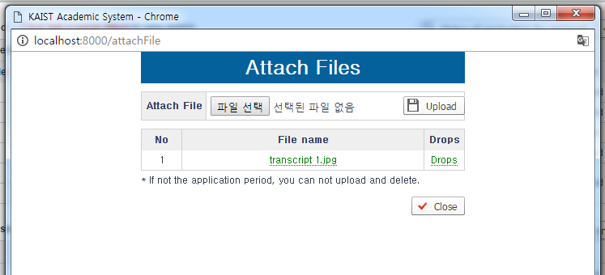
. Only image files in jpg, png, gif and tif formats are attachable.
. The file should be smaller than 2Mbytes.
. How to upload a transcript
1. Click “Choose File” and then your transcript file.
2. After clicking on your transcript file, click the “upload” button to upload it.
. The uploaded transcript information is shown on a list.
. When you click the file name, the transcript is downloaded.
. When you click the "Drops" link, the transcript is deleted.
. When the application period is over, you can only download the transcript.
※ You must submit the official copy of the transcript attached to the Academic Registrar's Team (Daejeon Campus) /College of Business (Seoul Campus).
2. Click "New".
3. Click "Search" button for "credits completed before admission", and a pop-up screen as shown below is created. You can search courses which are eligible.
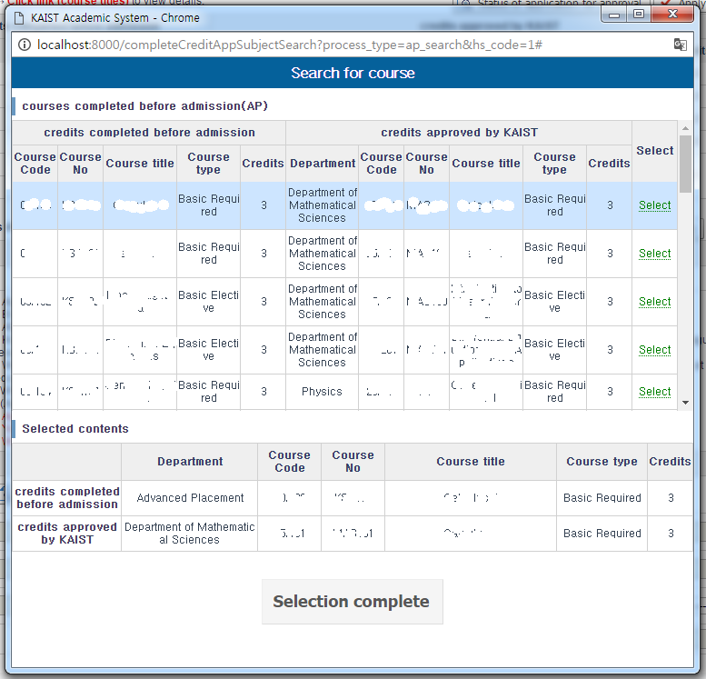
3-1. After checking "credits completed before admission" and "credits approved by KAIST", choose the course(s) you are going to apply for.
3-2. After confirming the details of the course(s) you are applying for on "Selected contents", click "Selection complete".
3-3 After you click "Selection complete", among the entries of both "credits completed before admission" and "credits approved by KAIST" the chosen course details are set as ineligible to Choose/Enter, and the pop-up screen closes.
4. Enter Grades, Year, Semester.
5. After modifying the entries eligible for Choose/Enter, click Apply/Save.

Modify
1. Click the course title link from "courses applied".
2. When you click the link, you can view the course details.
3. After modifying the entry eligible for Choose/Enter, click Apply/Save.
※ You can only modify AP courses.
※ You cannot modify courses which your adviser has already Approved/Returned.
※ You cannot modify course details which have already been set up through the pop-up screen.

2. Individual Advanced Placement Program
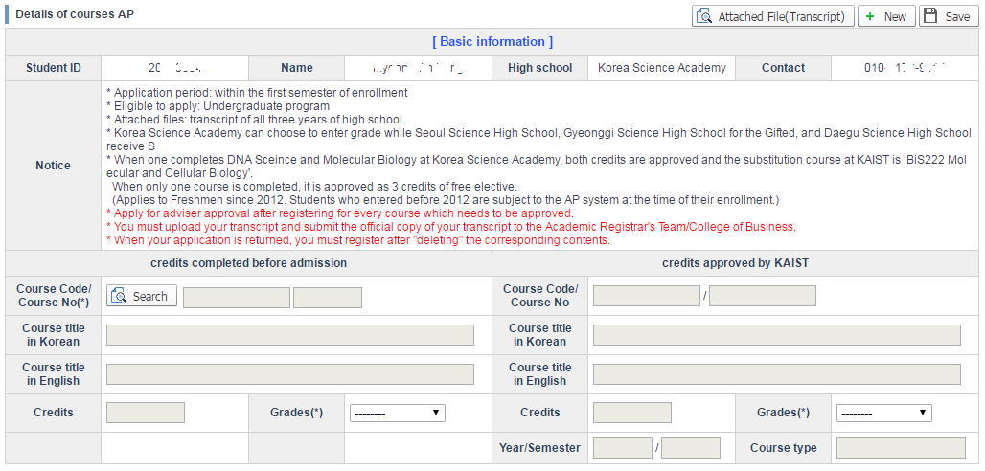
※ For AP, you must upload your transcript to apply for credit approval.

How to Register
1. Upload your transcript.
. Click the "Attach File(Transcript)" button and a pop-up screen as shown below will be created.
. Only image files in jpg, png, gif and tif formats are attachable.
. The file should be smaller than 2Mbytes.
. How to upload a transcript
1. Click “Choose File” and then your transcript file.
2. After clicking on your transcript file, click the “upload” button to upload it.
. The uploaded transcript information is shown on a list.
. When you click the file name, the transcript is downloaded.
. When you click the "Drops" link, the transcript is deleted.
. When the application period is over, you can only download the transcript.
※ You must submit the official copy of the transcript attached to the Academic Registrar's Team (Daejeon Campus) /College of Business (Seoul Campus).
2. Click "New".
3. Click "Search" button for "credits completed before admission", and a pop-up screen as shown below is created. You can search courses which are eligible.
3-1. After checking "credits completed before admission" and "credits approved by KAIST", choose the course(s) you are going to apply for.
3-2. After confirming the details of the course(s) you are applying for on "Selected contents", click "Selection complete".
3-3 After you click "Selection complete", among the entries of both "credits completed before admission" and "credits approved by KAIST" the chosen course details are set as ineligible to Choose/Enter, and the pop-up screen closes.
4. After modifying the entries eligible for Choose/Enter, click Apply/Save.

Modify
1. Click the course title link from "courses applied".
2. When you click the link, you can view the course details.
3. After modifying the entry eligible for Choose/Enter, click Apply/Save.
※ You can only modify AP courses.
※ You cannot modify courses which your adviser has already Approved/Returned.
※ You cannot modify course details which have already been set up through the pop-up screen.

3. Mutually Recognized/Cross-Registration/Honor
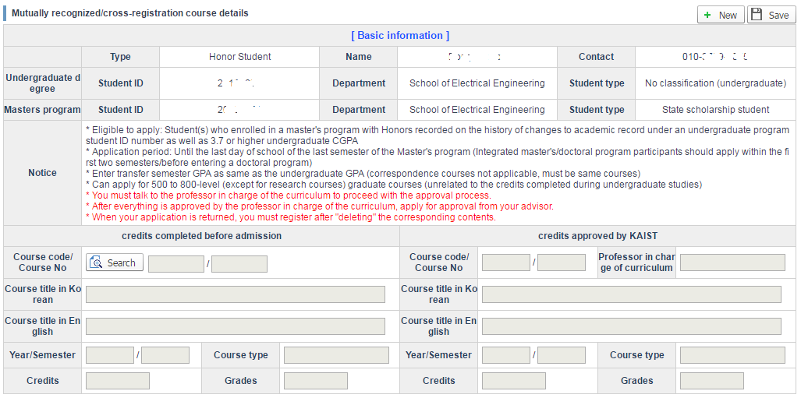

How to Register
1. Click "New".
2. Click the "Search" button in "credits completed before admission", and a pop-up screen as shown below is created. You can search eligible courses among the credits which you acquired during the undergraduate program.
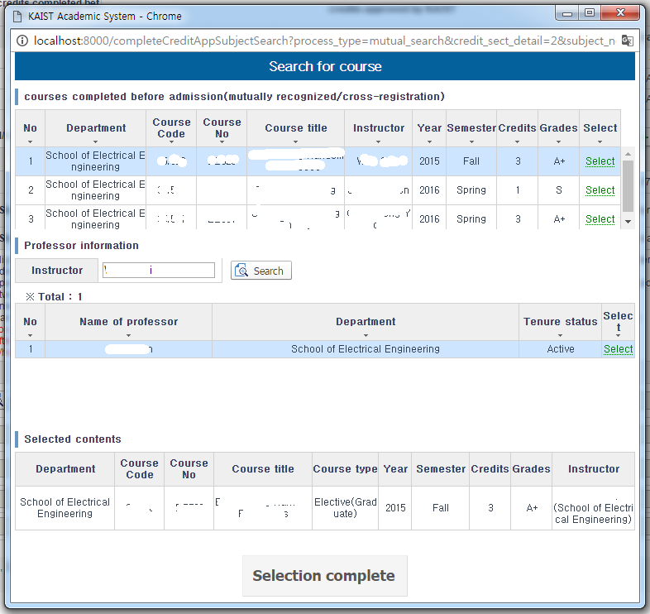
2-1. Choose the courses you are applying for.
2-2. When you choose a course, you can view the adviser, and if he/she is teaching that semester, he/she will automatically be selected.
※ If he/she is not teaching that semester, enter the name of the professor you will get approval from on the "Adviser" entry, and search for and select the professor.
2-3. After confirming the details of the courses you are applying for and the professor on "Chosen Courses", click "Selection complete".
2-4 After you click "Selection complete", among the entries of both "credits completed before admission" and "credits approved by KAIST" the chosen course details are set as ineligible to Choose/Enter, and the pop-up screen closes.
3. Click "Apply/Save".

4. Bridge Program
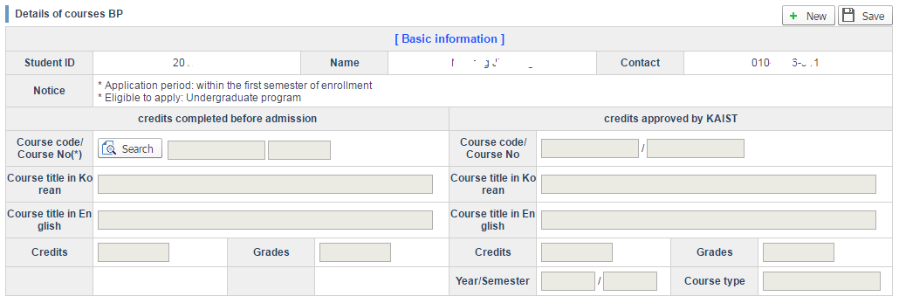

How to Register
1. Click "New".
2. Click the "Search" button in "credits completed before admission", and a pop-up screen as shown below is created. You can see the details of the completed Bridge Program credits.
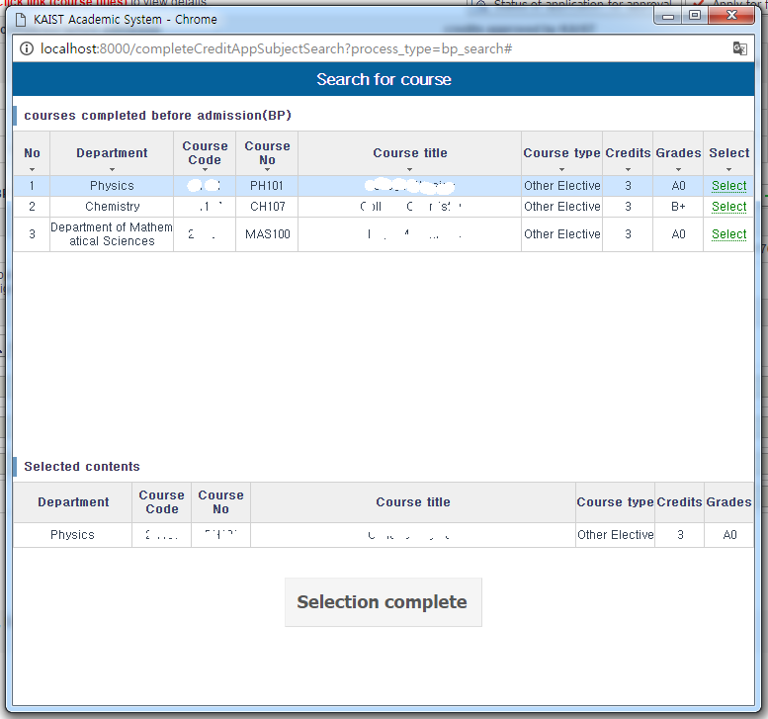
2-1. Choose the course(s) you are applying for.
2-2. After confirming the details of the courses you are applying for and the professor in "Chosen Courses", click "Selection complete".
2-3 After you click "Selection complete", among the entries of both "credits completed before admission" and "credits approved by KAIST" the chosen course details are set as ineligible to Choose/Enter, and the pop-up screen closes.
3. Click "Apply/Save".

5. Audited
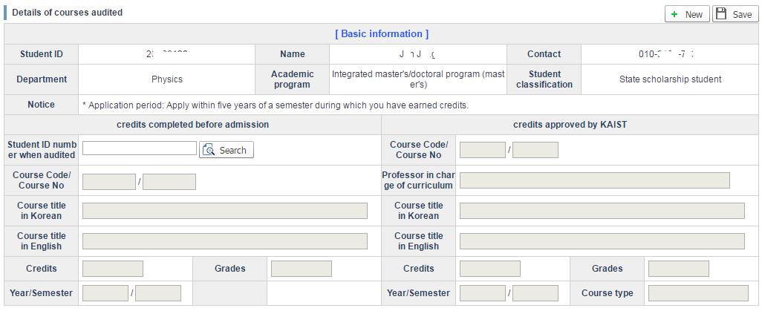

How to Register
1. Click "New".
2. Enter "Student ID Number for Auditing" and click "Search" then a pop-up screen as shown below is created. You can see the details of the completed credits under your Student ID number.
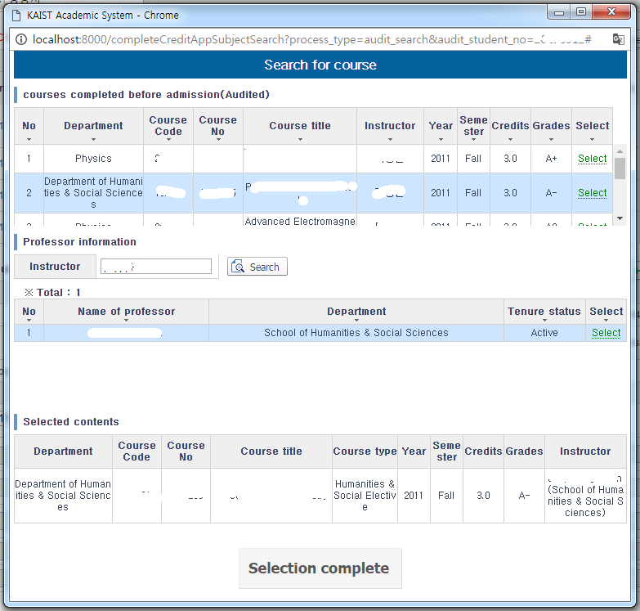
2-1. Choose the courses you are applying for.
2-2. When you choose the course, you can view the adviser, and if he/she is teaching that semester, he/she will be automatically selected.
※ If he/she is not teaching that semester, enter the name of the professor you will get approval from on the "Adviser" entry, and search for and select the professor.
2-3. After confirming the details of the course(s) you are applying for and the professors on "Chosen Courses", click "Selection complete".
2-4. After you click "Selection complete", among the entries of both "credits completed before admission" and "credits approved by KAIST" the chosen course details are set as ineligible to Choose/Enter, and the pop-up screen closes.
3. Click "Apply/Save".

6. Transfer to another Department
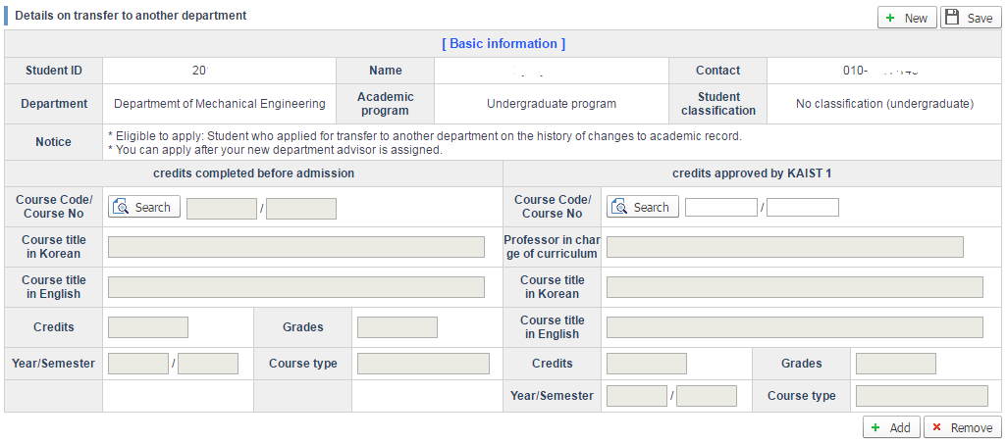

How to Register
1. Click "New".
2. Click the "Search" button in "credits completed before admission", and a pop-up screen as shown below is created. You can view the course details there.
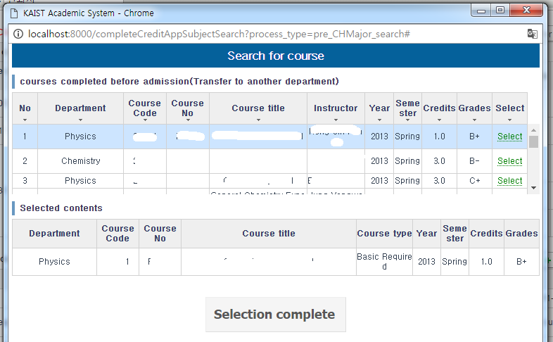
2-1. Choose the courses you are applying for.
2-2. After confirming the details of the courses you are applying for in "Chosen Courses", click "Selection complete".
2-3. After you click "Selection complete", among the entries of both "credits completed before admission" and "credits approved by KAIST", the corresponding course details are set on "Grade" and "Approved year/semester" entries, and the pop-up screen closes.
3. After entering the "Course Code/Course Number" in "credits approved by KAIST", click "Search". A pop-up screen as shown below appears, and you can see the courses which have been entered.
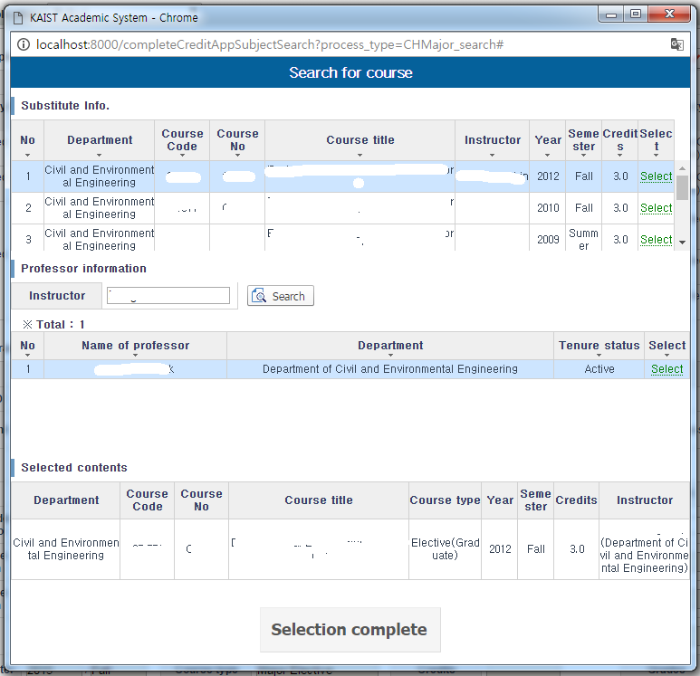
3-1. Select the substitute course(s).
3-2. When you choose a course, you can view the adviser, and if he/she is teaching that semester, he/she will be automatically selected.
※ If he/she is not teaching that semester, enter the name of the professor you will get approval from on the "Adviser" entry, and search for and select the professor.
3-3. After confirming the details of the courses you are applying for and the professor in "Chosen Courses", click "Selection complete".
3-4. After you click “Selection complete”, among the entries of both "credits completed before admission" and "credits approved by KAIST" the chosen course details are set as ineligible to Choose/Enter, and the pop-up screen closes.

4. Add/Remove Substitute Courses
4-1. Click "Add" to create a substitute course entry.
4-2. Click "Remove" to delete the final entry created in the Substitute Course entry. When there is only one entry, you cannot remove it.
5. Click "Apply/Save".
※ When the final staff approves so that credit transfer is completed, the grade gets replaced by that of the substitute course.

7. Credit Approval for PhD candidates who have changed departments
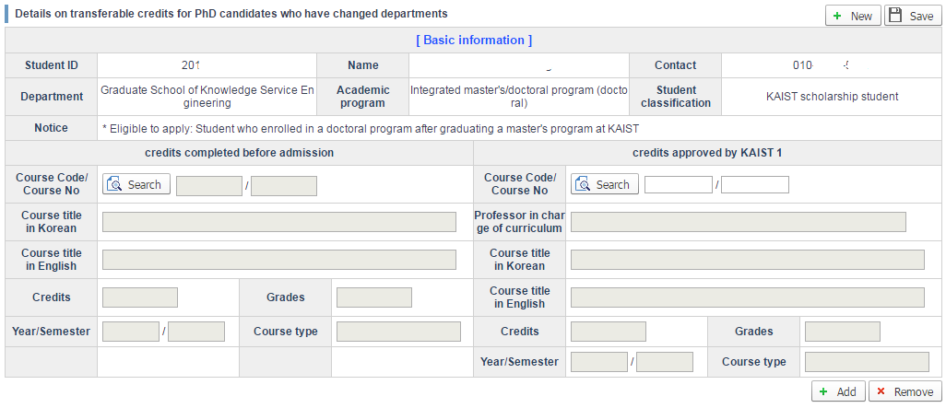

How to Register
1. Click "New".
2. Click the "View" button in "credits completed before admission", and a pop-up screen as shown below is created. You can view completed course details earned under a previous Master's Program ID number.
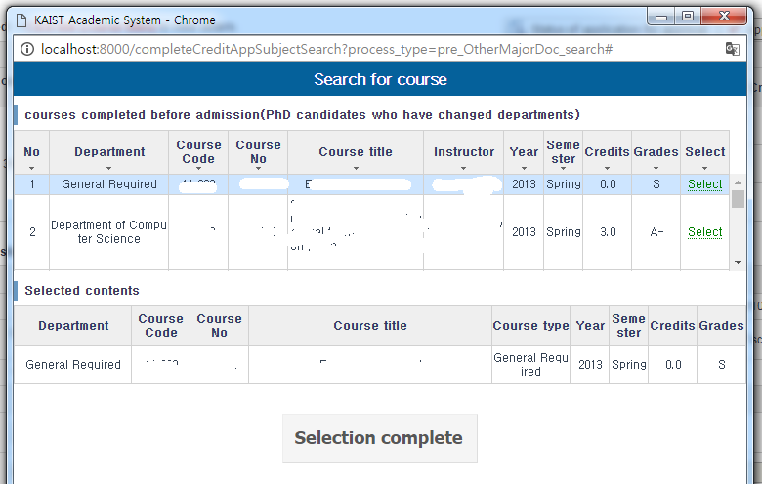
2-1. Choose the courses you are applying for.
2-2. After confirming the details of the courses you are applying for in "Chosen Course(s)", click "Selection complete".
2-3. After you click "Selection complete", among the entries of both "credits completed before admission" and "credits approved by KAIST", the corresponding course details are set on "Grade" and "Approved year/semester" entries, and the pop-up screen closes.
3. After you click "Selection complete", among the entries of both "credits completed before admission" and "credits approved by KAIST" the chosen course details are set as ineligible to Choose/enter, and the pop-up screen closes.
3-1. Choose Correspondence Courses.
3-2. When you choose the course, you can view the adviser, and if he/she is teaching that semester, he/she will be automatically selected.
※ If he/she is not teaching that semester, enter the name of the professor you will get approval from in the "Adviser" entry, and search for and select the professor.
3-3. After confirming the details of the courses you are applying for and the professor in "Chosen Courses", click "Selection complete".
3-4 After you click "Selection complete", among the entries of both "credits completed before admission" and "credits approved by KAIST" the chosen course details are set as ineligible to Choose/Enter, and the pop-up screen closes.
4. Add/Remove Correspondence Course
4-1. Click "Add" to create a Correspondence Course entry.
4-2. Click "Remove" to delete the final entry created in the Correspondence Course entry. When there is only one entry, you cannot remove it.
5. Click "Apply/Save".

8. Credits previously completed at KAIST
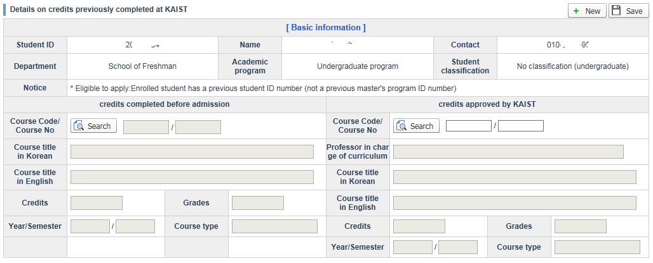

How to Register
1. Click "New".
2. Click the "Search" button in "credits completed before admission", and a pop-up screen as shown below is created. You can view completed course details earned under the previous Student ID number which matches the Resident Registration number of the current Student ID number (not the previous Master's program ID number and the current Student ID number).
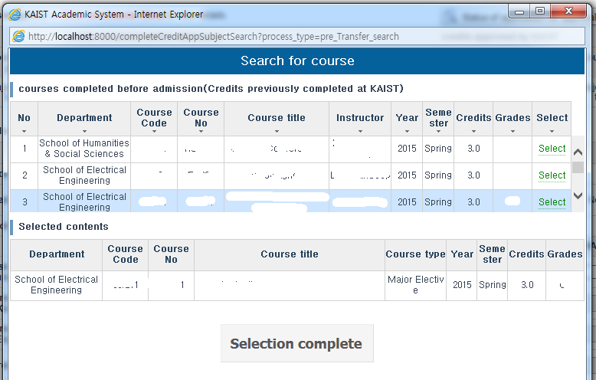
2-1. Choose the courses you are applying for.
2-2. After confirming the details of the courses you are applying for in "Chosen Course(s)", click "Selection complete".
2-3. After you click "Selection complete", among the entries of both "credits completed before admission" and "credits approved by KAIST", the corresponding course details are set on "Grade" and "Approved year/semester" entries, and the pop-up screen closes.
3. After you click "Selection complete", among the entries of both "credits completed before admission" and "credits approved by KAIST" the chosen course details are set as ineligible to Choose/enter, and the pop-up screen closes.
3-1. Choose Correspondence Courses.
3-2. When you choose the course, you can view the adviser, and if he/she is teaching that semester, he/she will be automatically selected.
※ If he/she is not teaching that semester, enter the name of the professor you will get approval from in the "Adviser" entry, and search for and select the professor.
3-3. After confirming the details of the courses you are applying for and the professor in "Chosen Courses", click "Selection complete".
3-4 After you click "Selection complete", among the entries of both "credits completed before admission" and "credits approved by KAIST" the chosen course details are set as ineligible to Choose/Enter, and the pop-up screen closes.
4. Click "Apply/Save".

End.
Created with the Personal Edition of HelpNDoc: Free HTML Help documentation generator

Apply School register change
1. Purpose and Background of Applying for Changes to Registration Status
Students currently enrolled or on a leave of absence may apply for changes to their registration status through the system, e.g. a leave of absence, an extension of their leave of absence, academic reinstatement, dispatch (for studying abroad) without a leave of absence, or voluntary withdrawal.

2. Menu
Registration Status > Apply for Changes to Registration Status

3. Authorized Users
- All the students currently enrolled or on a leave of absence

4. Display and Explanation
a. Registration status change list
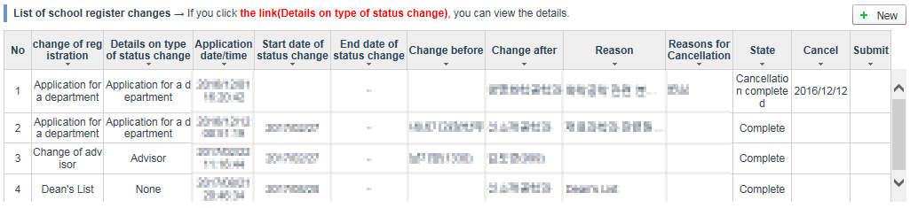
- You can view details of changes to your registration status applied for and approved.

b. Applying for changes to registration status
- Click the New button to call up the pop-up screen for choosing a status change type.
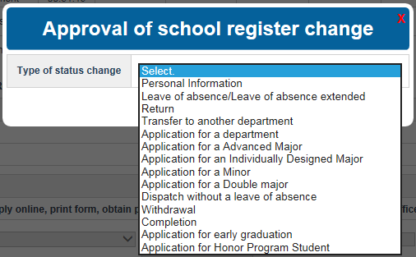
- Choose the status change type you want to apply for and then click the Newly Apply button.

[Personal Information]
(1) Application
- After clicking the New button, choose Personal Information on the pop-up screen for registration status changes and then click the Newly Apply button.
- Only students currently enrolled or on a leave of absence may apply for a change in their registration status.
- If there is already the same registration status change being applied for, the following message is output:

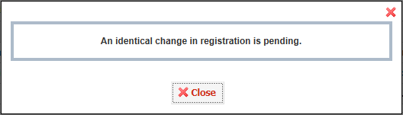

* Detailed status change type – when applying for a name change
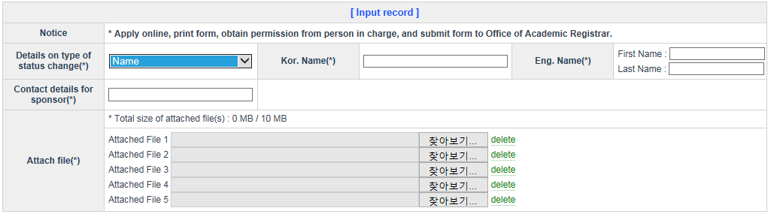
- Choose the detailed status change type, “Name”.
- Enter the name in full to be changed in both Korean and English (required).
- Enter the contact information of your parents (required).
- Upload the attached file(s) (required).
- You can upload only the attached files with one of these file extensions: jpg, gif, png and tif.
- Click the Apply (Save) button to complete the application.

* Detailed status change type – when applying for a resident registration number change
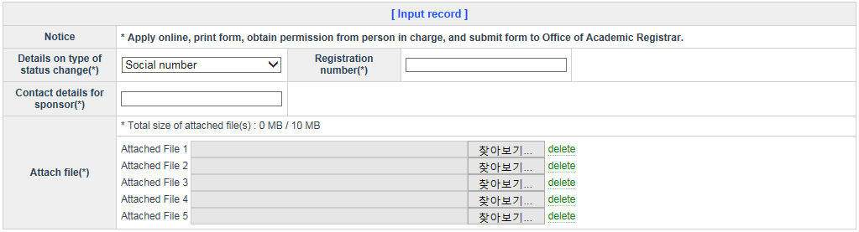
- Choose the detailed status change type, “Resident Registration Number”.
- Enter the resident registration number to be changed (required).
- Enter the contact information of your parents (required).
- Upload the attached file(s) (required).
- You can upload only the attached files with one of these file extensions: jpg, gif, png and tif.
- Click the Apply (Save) button to complete the application.

* Detailed status change type - when applying for a nationality change
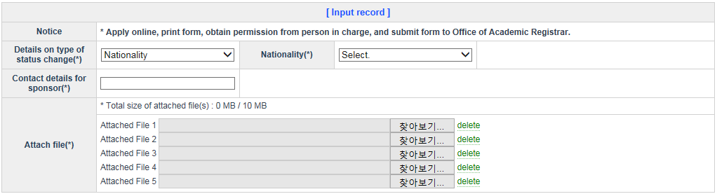
- Choose the detailed status change type, “Nationality”.
- Enter the nationality to be changed (required).
- Enter the contact information of your parents (required).
- Upload the attached file(s) (required).
- You can upload only the attached files with one of these file extensions: jpg, gif, png and tif.
- Click the Apply (Save) button to complete the application.

(2) Viewing and modifying detailed information
- You can search for and view detailed information on the application for the registration status change and the approval progress status thereof before final approval or cancellation thereof.
- You can modify the content of your application for the registration status change before the final person in charge approves it.

(3) Canceling the application
- You can cancel your application for the registration status change by clicking the “Cancel Application” link on the registration status change list.

[Leave of Absence/Extension of Leave of Absence]
(1) Application
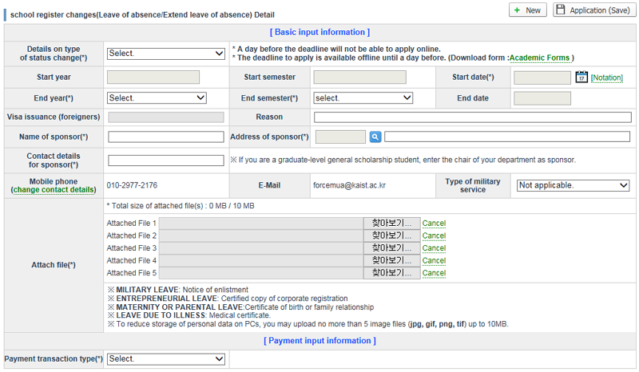
- After clicking the New button, choose Leave of Absence on the pop-up screen for registration status changes and then click the Newly Apply button.
- Among the detailed status change types, only the ones you can apply for based on the academic calendar are displayed.
- Once you have chosen a detailed status change type, the starting year, the starting semester and the starting day are automatically set and you can only change the starting day.
- Once you have chosen the ending year and the ending semester, the ending day is automatically set and you cannot change it.
- If you are a foreigner, you must enter your visa number.
- When choosing General Leave of Absence (Other) among the detailed status change types, you must enter the items of reasons for choosing it.
- It is necessary to enter guarantor information.
- After clicking the Change Contact Information link, you can modify your mobile phone number and/or email information.
- The items for a student’s military classification may differ according to the conditions pertinent to his situation. You can choose the relevant item(s).
- The part of processing the paid tuition fees includes the Unpaid Tuition Fees/Scholarships and Fee Remissions item, the Apply for Carry-over item, and the Apply for Tuition Refund item. In the case of the Unpaid Tuition Fees/Scholarships and Fee Remissions item, you must enter an attached file containing the bank account number, the name of the account holder, and a copy of the bankbook (passbook).
- You must upload the attached file(s) depending on the type of leave of absence, and you can upload only the attached files with one of these file extensions: jpg, gif, png and tif.
- If you press the Apply button after entering the relevant items, you can see informative phrases including the submission deadline after checking the conditions for a leave of absence.

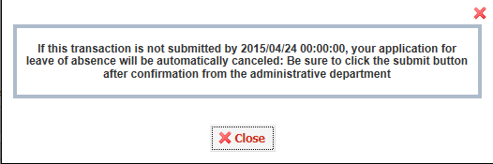

(2) Viewing and modifying detailed information
- You can search for and view detailed information on the application for the registration status change and the approval progress status thereof before final approval or cancellation thereof.
- You can modify the content of your application for the registration status change before cancellation or if the first person in charge has not undertaken the approval process yet.

(3) Canceling the application
- You can cancel your application for the registration status change by clicking the “Cancel Application” link on the registration status change list.

(4) Submission
- At the submission stage, submit your application for the registration status change by clicking the “Submit” link on the registration status change list (except in the case of extending your leave of absence).

[Reinstatement]
(1) Application
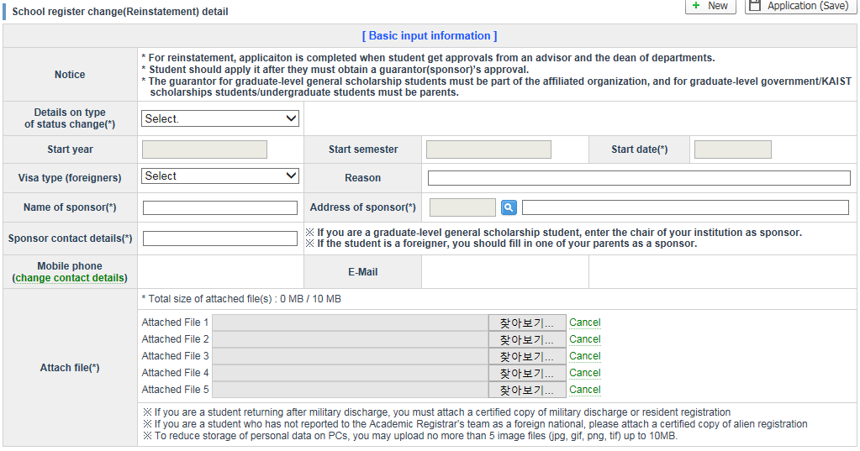
- After clicking the New button, choose Reinstatement on the pop-up screen for registration status changes and then click the Newly Apply button.
- Among the detailed status change types, only the ones you can apply for based on the academic calendar are displayed.
- Once you have chosen a detailed status change type, the starting year, the starting semester and the starting day are automatically set and you can change none of them.
- If you are a foreigner, you must enter your visa number.
- It is necessary to enter guarantor information.
- After clicking the Change Contact Information link, you can modify your mobile phone number and/or email information.
- You must upload the attached file(s) depending on the detailed status change type, and you can upload only the attached files with one of these file extensions: jpg, gif, png and tif.
- After entering the relevant items, click the Apply button to complete the application.

(2) Viewing and modifying detailed information
- You can search for and view detailed information on the application for the registration status change and the approval progress status thereof before final approval or cancellation thereof.
- You can modify the content of your application for the registration status change before cancellation or if the first person in charge has not undertaken the approval process yet.

(3) Canceling the application
- You can cancel your application for the registration status change by clicking the “Cancel Application” link on the registration status change list.

[Transfer to another Department]
(1) Application
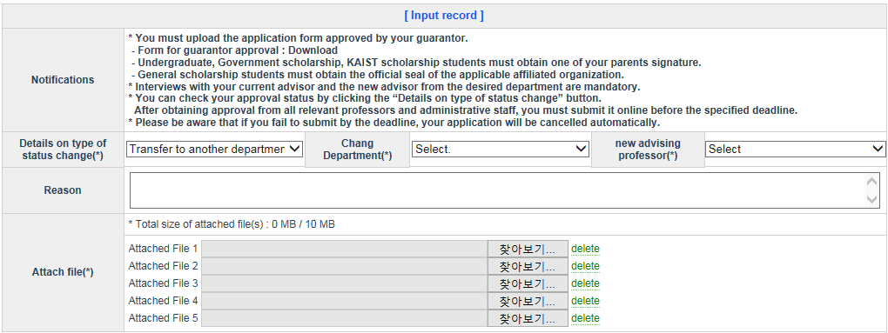
- After clicking the New button, choose Transfer to another Department on the pop-up screen for registration status changes and then click the Newly Apply button.
- If now is not the time included in the application period, a message is output.
- If it is not what you can apply for, a message is output.
- If there is already the same registration status change being applied for, the following message is output:
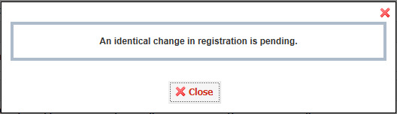
- Choose the department you want to transfer to.
- If you choose the department you want to transfer to, you can view a list of academic advisers in the department you are applying for.
- You must choose an adviser in the department you are applying for after consultation with your present department and professor.
- Enter the reason(s) for transferring to another department.
- You must upload an application form containing your guarantor’s signature as an attached file.
- You can upload only the attached files with one of these file extensions: jpg, gif, png and tif.
- Click the Apply (Save) button to complete the application.

(2) Viewing and modifying detailed information
- You can search for and view detailed information on the application for the registration status change and the approval progress status thereof before final approval or cancellation thereof.
- You can modify the content of your application for the registration status change before cancellation or if the first person in charge has not undertaken the approval process yet.

(3) Canceling the application
- You can cancel your application for the registration status change by clicking the “Cancel Application” link on the registration status change list before submission.

(4) Submission
- At the submission stage, submit your application for the registration status change by clicking the “Submit” link on the registration status change list.

[Applying for a Department]
(1) Application
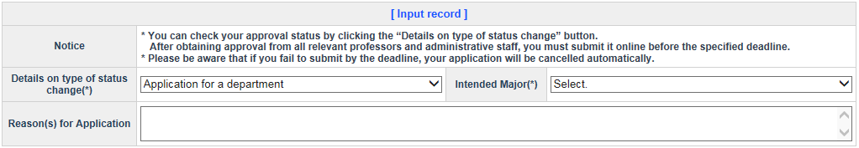
- After clicking the New button, choose Apply for Department on the pop-up screen for registration status changes and then click the Newly Apply button.
- If now is not the time included in the application period, a message is output.
- If it is not what you can apply for, a message is output.
- Choose the department you want to apply for.
- If you choose School of Business and Technology Management in terms of the department you want to apply for, choose the second department you want to apply for as well.
- Click the Apply (Save) button to complete the application.

(2) Viewing and modifying detailed information
- You can search for and view detailed information on the application for the registration status change and the approval progress status thereof before final approval or cancellation thereof.
- You can modify the content of your application for the registration status change before cancellation or if the first person in charge has not undertaken the approval process yet.

(3) Canceling the application
- You can cancel your application for the registration status change by clicking the “Cancel Application” link on the registration status change list.

(4) Submission
- At the submission stage, submit your application for the registration status change by clicking the “Submit” link on the registration status change list.

[Advanced Major]
(1) Application
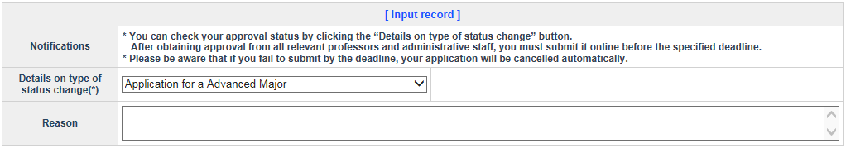
- After clicking the New button, choose Advanced Major on the pop-up screen for registration status changes and then click the Newly Apply button.
- If now is not the time included in the application period, a message is output.
- If it is not what you can apply for, a message is output.
- If there is already the same registration status change being applied for, the following message is output:
- Choose the detailed status change type you want to apply for and enter the reason(s) for applying for it.
- Click the Apply (Save) button to complete the application.

(2) Viewing and modifying detailed information
- You can search for and view detailed information on the application for the registration status change and the approval progress status thereof before final approval or cancellation thereof.
- You can modify the content of your application for the registration status change before cancellation or if the first person in charge has not undertaken the approval process yet.

(3) Canceling the application
- You can cancel your application for the registration status change by clicking the “Cancel Application” link on the registration status change list before submission.

(4) Submission
- At the submission stage, submit your application for the registration status change by clicking the “Submit” link on the registration status change list.

[Individually Designed Major]
(1) Application
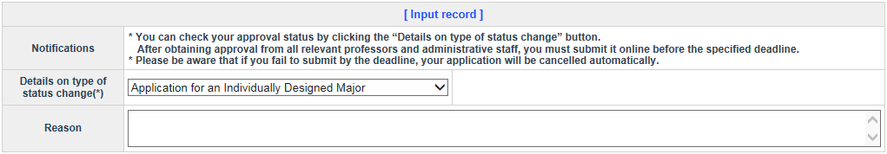
- After clicking the New button, choose Individually Designed Major on the pop-up screen for registration status changes and then click the Newly Apply button.
- If now is not the time included in the application period, a message is output.
- If it is not what you can apply for, a message is output.
- If there is already the same registration status change being applied for, the following message is output:
- Choose the detailed status change type you want to apply for and enter the reason(s) for applying for it.
- Click the Apply (Save) button to complete the application.

(2) Viewing and modifying detailed information
- You can search for and view detailed information on the application for the registration status change and the approval progress status thereof before final approval or cancellation thereof.
- You can modify the content of your application for the registration status change before cancellation or if the first person in charge has not undertaken the approval process yet.

(3) Canceling the application
- You can cancel your application for the registration status change by clicking the “Cancel Application” link on the registration status change list before submission.

(4) Submission
- At the submission stage, submit your application for the registration status change by clicking the “Submit” link on the registration status change list.

[Minor]
(1) Application
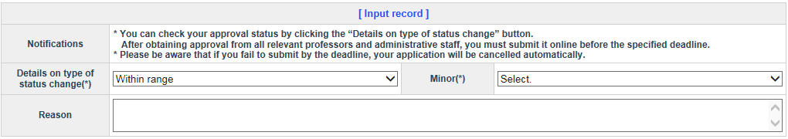
- After clicking the New button, choose Minor on the pop-up screen for registration status changes and then click the Newly Apply button.
- If now is not the time included in the application period, a message is output.
- If it is not what you can apply for, a message is output.
- If there is already the same registration status change being applied for, the following message is output:
- Choose the detailed status change type you want to apply for and enter the reason(s) for applying for it.
- Click the Apply (Save) button to complete the application.

(2) Viewing and modifying detailed information
- You can search for and view detailed information on the application for the registration status change and the approval progress status thereof before final approval or cancellation thereof.
- You can modify the content of your application for the registration status change before cancellation or if the first person in charge has not undertaken the approval process yet.

(3) Canceling the application
- You can cancel your application for the registration status change by clicking the “Cancel Application” link on the registration status change list before submission.

(4) Submission
- At the submission stage, submit your application for the registration status change by clicking the “Submit” link on the registration status change list.

[Double Major]
(1) Application
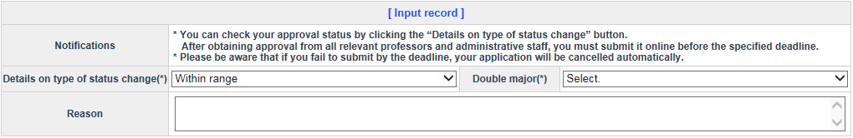
- After clicking the New button, choose Double Major on the pop-up screen for registration status changes and then click the Newly Apply button.
- If now is not the time included in the application period, a message is output.
- If it is not what you can apply for, a message is output.
- If there is already the same registration status change being applied for, the following message is output:
- Choose the detailed status change type you want to apply for and enter the reason(s) for applying for it.
- Click the Apply (Save) button to complete the application.

(2) Viewing and modifying detailed information
- You can search for and view detailed information on the application for the registration status change and the approval progress status thereof before final approval or cancellation thereof.
- You can modify the content of your application for the registration status change before cancellation or if the first person in charge has not undertaken the approval process yet.

(3) Canceling the application
- You can cancel your application for the registration status change by clicking the “Cancel Application” link on the registration status change list before submission.

(4) Submission
- At the submission stage, submit your application for the registration status change by clicking the “Submit” link on the registration status change list.

[Interdisciplinary Major]
(1) Application
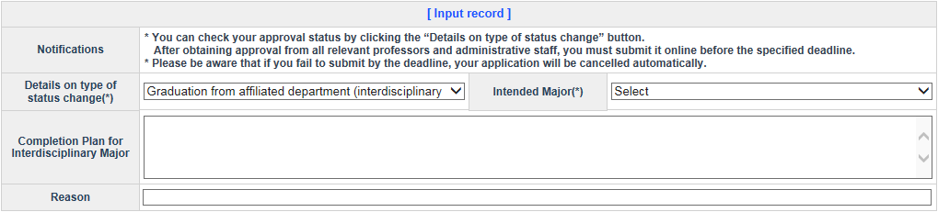
- After clicking the New button, choose Interdisciplinary Major on the pop-up screen for registration status changes and then click the Newly Apply button.
- If now is not the time included in the application period, a message is output.
- If it is not what you can apply for, a message is output.
- If there is already the same registration status change being applied for, the following message is output:
- Choose a detailed status change type and an interdisciplinary major you want to apply for and then enter your interdisciplinary major completion plan.
- Click the Apply (Save) button to complete the application.

(2) Viewing and modifying detailed information
- You can search for and view detailed information on the application for the registration status change and the approval progress status thereof before final approval or cancellation thereof.
- You can modify the content of your application for the registration status change before cancellation or if the first person in charge has not undertaken the approval process yet.

(3) Canceling the application
- You can cancel your application for the registration status change by clicking the “Cancel Application” link on the registration status change list before submission.

(4) Submission
- At the submission stage, submit your application for the registration status change by clicking the “Submit” link on the registration status change list.

[Changing My Organization]
(1) Application
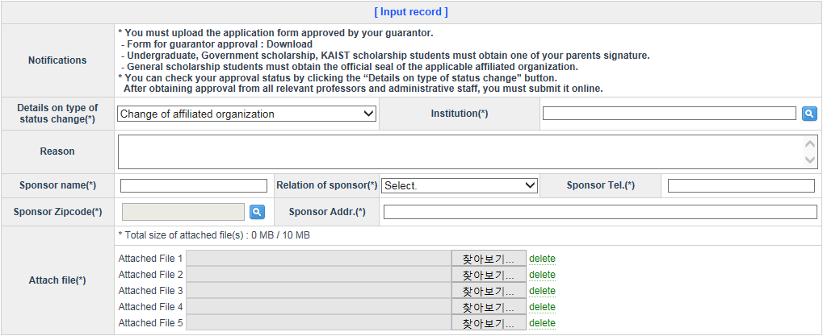
- After clicking the New button, choose Change My Organization on the pop-up screen for registration status changes and then click the Newly Apply button.
- If now is not the time included in the application period, a message is output.
- If there is already the same registration status change being applied for, the following message is output:
- Enter the detailed status change type, the reason(s) for the intended change, and the guarantor information.
- Search for and view your organization through a pop-up screen and then choose it.
- You must upload an application form containing your guarantor’s signature as an attached file.
- You can upload only the attached files with one of these file extensions: jpg, gif, png and tif.
- Click the Apply (Save) button to complete the application.

(2) Viewing and modifying detailed information
- You can search for and view detailed information on the application for the registration status change and the approval progress status thereof before final approval or cancellation thereof.
- You can modify the content of your application for the registration status change before cancellation or if the first person in charge has not undertaken the approval process yet.

(3) Canceling the application
- You can cancel your application for the registration status change by clicking the “Cancel Application” link on the registration status change list before submission.

(4) Submission
- At the submission stage, submit your application for the registration status change by clicking the “Submit” link on the registration status change list.

[Changing the Student Classification]
(1) Application
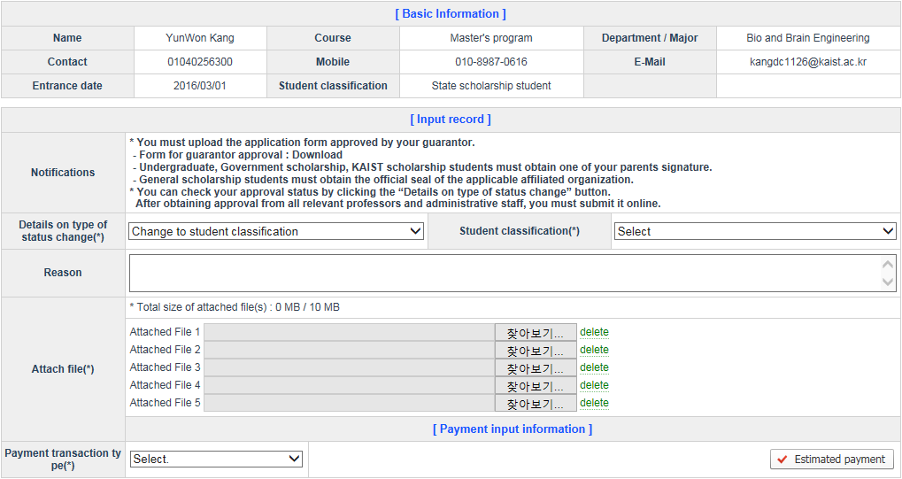
- After clicking the New button, choose Change Student Classification on the pop-up screen for registration status changes and then click the Newly Apply button.
- If it is not what you can apply for, a message is output.
- If there is already the same registration status change being applied for, the following message is output:
- Enter the detailed status change type, the reason(s) for the intended change, and the guarantor information.
- You must upload an application form containing your guarantor’s signature as an attached file.
- You can upload only the attached files with one of these file extensions: jpg, gif, png and tif.
- Click the Apply (Save) button to complete the application.

(2) Viewing and modifying detailed information
- You can search for and view detailed information on the application for the registration status change and the approval progress status thereof before final approval or cancellation thereof.
- You can modify the content of your application for the registration status change before cancellation or if the first person in charge has not undertaken the approval process yet.

(3) Canceling the application
- You can cancel your application for the registration status change by clicking the “Cancel Application” link on the registration status change list before submission.

(4) Submission
- At the submission stage, submit your application for the registration status change by clicking the “Submit” link on the registration status change list.

[Dispatch without a Leave of Absence]
(1) Application
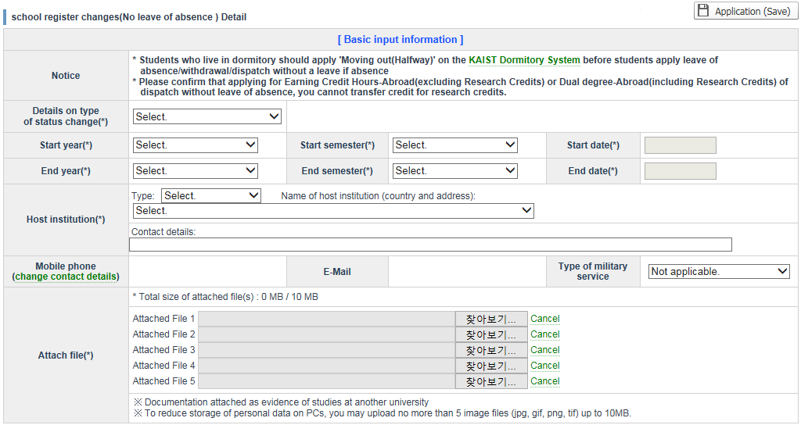
- After clicking the New button, choose Dispatch without a Leave of Absence on the pop-up screen for registration status changes and then click the Newly Apply button.
- Choose one program as a detailed status change type from among the Thesis Research Program, the Credit Acquisition Program, the Dual Degree Program, and the Internship Program.
- If you choose the starting year and the starting semester, the semester starting day will be automatically set as the starting day, and you can change the starting day.
- If you choose the ending year and the ending semester, the semester ending day will be automatically set as the ending day, and you can change the ending day.
- Enter all the information on the institution where you will study.
- After clicking the Change Contact Information link, you can modify your mobile phone number and/or email information.
- Your military classification may be changed according to your situation. Choose the relevant item(s).
- You must upload the attached file(s) depending on the detailed status change type, and you can upload only the attached files with one of these file extensions: jpg, gif, png and tif.
- After entering the item(s), click the Apply button to complete the application.

(2) Viewing and modifying detailed information
- You can search for and view detailed information on the application for the registration status change and the approval progress status thereof before final approval or cancellation thereof.
- You can modify the content of your application for the registration status change before cancellation or if the first person in charge has not undertaken the approval process yet.

(3) Canceling the application
- You can cancel your application for the registration status change by clicking the “Cancel Application” link on the registration status change list.

(4) Submission
- At the submission stage, submit your application for the registration status change by clicking the “Submit” link on the registration status change list.

[Voluntary Withdrawal]
(1) Application
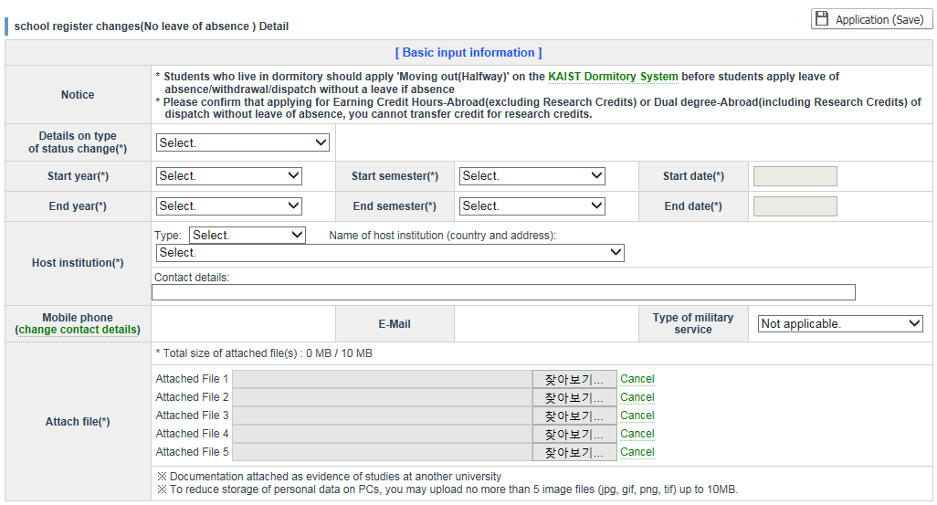
- After clicking the New button, choose Voluntary Withdrawal on the pop-up screen for registration status changes and then click the Newly Apply button.
- Choose a detailed status change type without fail.
- If you choose the starting year and the starting semester, the semester starting day will be automatically set as the starting day, and you can change the starting day.
- If you are a foreigner, you must enter your visa number.
- It is necessary to enter guarantor information.
- After clicking the Change Contact Information link, you can modify your mobile phone number and/or email information.
- The items for a student’s military classification may differ according to the conditions pertinent to his situation. You can choose the relevant item(s).
- The part of processing the paid tuition fees includes the Unpaid Tuition Fees/Scholarships and Fee Remissions item, the Apply for Carry-over item, and the Apply for Tuition Refund item. In the case of the Unpaid Tuition Fees/Scholarships and Fee Remissions item, you must enter an attached file containing the bank account number, the name of the account holder, and a copy of the bankbook (passbook).
- You can upload only the attached files with one of these file extensions: jpg, gif, png and tif.
- Before applying for it, you must confirm the details of returned benefit payments by clicking the Return Benefit Payment button.
- If you press the Apply button after entering the relevant items, you can see informative phrases including the submission deadline.

(2) Viewing and modifying detailed information
- You can search for and view detailed information on the application for the registration status change and the approval progress status thereof before final approval or cancellation thereof.
- You can modify the content of your application for the registration status change before cancellation or if the first person in charge has not undertaken the approval process yet.

(3) Canceling the application
- You can cancel your application for the registration status change by clicking the “Cancel Application” link on the registration status change list.

(4) Submission
- At the submission stage, submit your application for the registration status change by clicking the “Submit” link on the registration status change list.

[Completion]
(1) Application
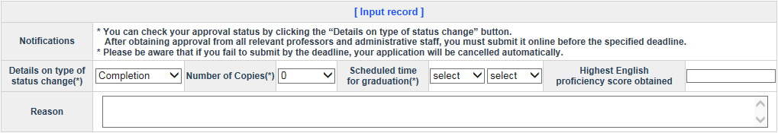
- After clicking the New button, choose Course Completion on the pop-up screen for registration status changes and then click the Newly Apply button.
- If now is not the time included in the application period, a message is output.
- If it is not what you can apply for, a message is output.
- If there is already the same registration status change being applied for, the following message is output:
- Choose or enter the detailed status change type, the number of copies to be applied for, the scheduled time for graduation, and the highest English proficiency score obtained.
- Click the Apply (Save) button to complete the application.

(2) Viewing and modifying detailed information
- You can search for and view detailed information on the application for the registration status change and the approval progress status thereof before final approval or cancellation thereof.
- You can modify the content of your application for the registration status change before cancellation or if the first person in charge has not undertaken the approval process yet.

(3) Canceling the application
- You can cancel your application for the registration status change by clicking the “Cancel Application” link on the registration status change list before submission.

(4) Submission
- At the submission stage, submit your application for the registration status change by clicking the “Submit” link on the registration status change list.

[Early Graduation]
(1) Application
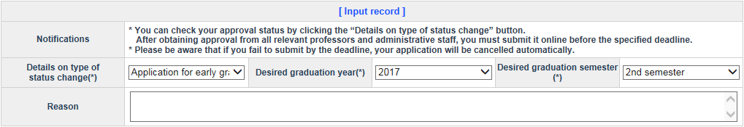
- After clicking the New button, choose Early Graduation on the pop-up screen for registration status changes and then click the Newly Apply button.
- If now is not the time included in the application period, a message is output.
- If it is not what you can apply for, a message is output.
- If there is already the same registration status change being applied for, the following message is output:
- Choose a detailed status change type and enter the reason(s) for applying for it.
- The desired graduation year and the desired graduation semester are automatically set.
- Click the Apply (Save) button to complete the application.

(2) Viewing and modifying detailed information
- You can search for and view detailed information on the application for the registration status change and the approval progress status thereof before final approval or cancellation thereof.
- You can modify the content of your application for the registration status change before cancellation or if the first person in charge has not undertaken the approval process yet.

(3) Canceling the application
- You can cancel your application for the registration status change by clicking the “Cancel Application” link on the registration status change list before submission.

(4) Submission
- At the submission stage, submit your application for the registration status change by clicking the “Submit” link on the registration status change list.

[Applying for Part-Time Student Status]
(1) Application
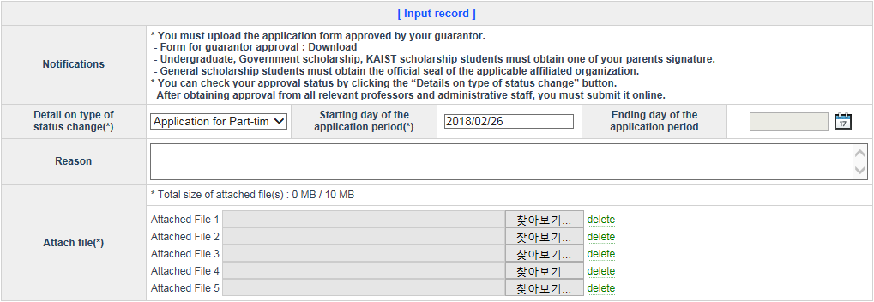
- After clicking the New button, choose Apply for Part-Time Student Status on the pop-up screen for registration status changes and then click the Newly Apply button.
- If now is not the time included in the application period, a message is output.
- If it is not what you can apply for, a message is output.
- If there is already the same registration status change being applied for, the following message is output:
- The starting day of the application period is automatically set and entered as the starting day of the semester.
- Choose the detailed status change type to be applied for and enter the ending day of the application period and the reason(s) for applying for it.
- You must enter an application form containing the signature of the head of your organization as an attached file.
- You can upload only the attached files with one of these file extensions: jpg, gif, png and tif.
- Click the Apply (Save) button to complete the application.

(2) Viewing and modifying detailed information
- You can search for and view detailed information on the application for the registration status change and the approval progress status thereof before final approval or cancellation thereof.
- You can modify the content of your application for the registration status change before cancellation or if the first person in charge has not undertaken the approval process yet.

(3) Canceling the application
- You can cancel your application for the registration status change by clicking the “Cancel Application” link on the registration status change list before submission.

(4) Submission
- At the submission stage, submit your application for the registration status change by clicking the “Submit” link on the registration status change list.

[Applying for Full-Time Student Status]
(1) Application
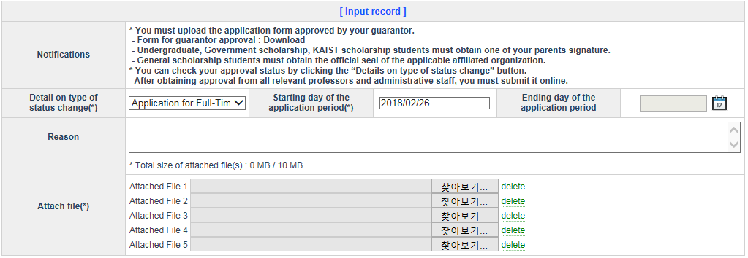
- After clicking the New button, choose Apply for Full-Time Student Status on the pop-up screen for registration status changes and then click the Newly Apply button.
- If now is not the time included in the application period, a message is output.
- If it is not what you can apply for, a message is output.
- If there is already the same registration status change being applied for, the following message is output:
- The starting day of the application period is automatically set and entered as the starting day of the semester.
- Choose the detailed status change type and enter the ending day of the application period and the reason(s) for applying for it.
- You must enter an application form containing the signature of the head of your organization as an attached file.
- You can upload only the attached files with one of these file extensions: jpg, gif, png and tif.
- Click the Apply (Save) button to complete the application.

(2) Viewing and modifying detailed information
- You can search for and view detailed information on the application for the registration status change and the approval progress status thereof before final approval or cancellation thereof.
- You can modify the content of your application for the registration status change before cancellation or if the first person in charge has not undertaken the approval process yet.

(3) Canceling the application
- You can cancel your application for the registration status change by clicking the “Cancel Application” link on the registration status change list before submission.

(4) Submission
- At the submission stage, submit your application for the registration status change by clicking the “Submit” link on the registration status change list.

[Coursework Master’s Degree]
(1) Application
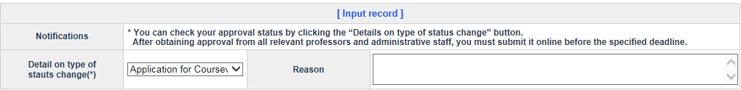
- After clicking the New button, choose Coursework Master’s Degree on the pop-up screen for registration status changes and then click the Newly Apply button.
- If now is not the time included in the application period, a message is output.
- If it is not what you can apply for, a message is output.
- If there is already the same registration status change being applied for, the following message is output:
- Choose the detailed status change type and enter the reason(s) for applying for it.
- Click the Apply (Save) button to complete the application.

(2) Viewing and modifying detailed information
- You can search for and view detailed information on the application for the registration status change and the approval progress status thereof before final approval or cancellation thereof.
- You can modify the content of your application for the registration status change before cancellation or if the first person in charge has not undertaken the approval process yet.

(3) Canceling the application
- You can cancel your application for the registration status change by clicking the “Cancel Application” link on the registration status change list before submission.

(4) Submission
- At the submission stage, submit your application for the registration status change by clicking the “Submit” link on the registration status change list.

[Applying for an Honor Program]
(1) Application
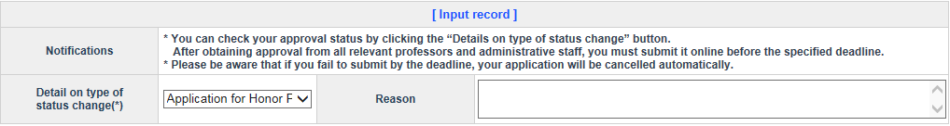
- After clicking the New button, choose Apply for Honor Program on the pop-up screen for registration status changes and then click the Newly Apply button.
- If now is not the time included in the application period, a message is output.
- If it is not what you can apply for, a message is output.
- If there is already the same registration status change being applied for, the following message is output:
- Choose the detailed status change type and enter the reason(s) for applying for it.
- Click the Apply (Save) button to complete the application.

(2) Viewing and modifying detailed information
- You can search for and view detailed information on the application for the registration status change and the approval progress status thereof before final approval or cancellation thereof.
- You can modify the content of your application for the registration status change before cancellation or if the first person in charge has not undertaken the approval process yet.

(3) Canceling the application
- You can cancel your application for the registration status change by clicking the “Cancel Application” link on the registration status change list before submission.

(4) Submission
- At the submission stage, submit your application for the registration status change by clicking the “Submit” link on the registration status change list.

[Approval Progress Status of the Application for Registration Status Change]
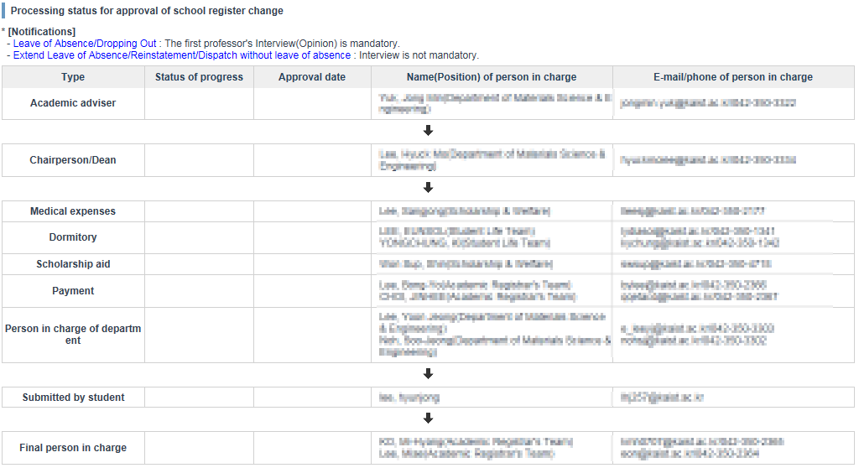
-“Waiting”, “Passed”, “Returned”, “Canceled”, “Shelved”, “Approved”, or “Submitted” is indicated in the Progress Status screen.
- If “Shelved” is indicated, you can confirm the content of shelving by clicking [View Content].
- In the case of the first professor approval, [Personal meeting] is indicated in the Progress Status screen, and you can confirm the content of the personal meeting by moving the mouse pointer.
- As for the content of anything completed, canceled or returned, each date of processing is shown on the date of approval.

c. Canceling the completion of registration status changes
※ You can cancel the completion of only any change in your registration status such as in the case of an advanced major, individually designed major, minor, interdisciplinary major, coursework master’s degree or integrated master’s and doctoral degree program.

[Canceling the Completion of Application for Advanced Major]
(1) Application
- You can view the details of the registration status change only when there are application details of the advanced major applied for. Click the Cancel Completion link of the details you want to cancel. 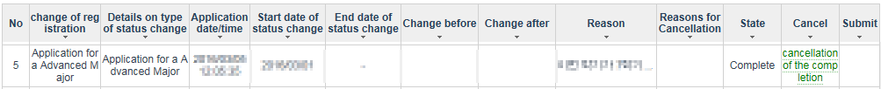
- After entering the reason(s) for canceling it, click the Apply button to complete the application for cancellation of the completion.
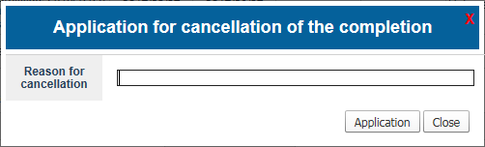
- Click the Apply for Cancellation (Save) button [marked with No. 3] to complete the application for cancellation thereof.

(2) Detailed information
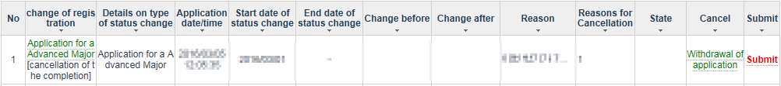
- By clicking the Status Change Type link, you can search for and view details of such application and the approval progress status of the application for the registration status change.

(3) Withdrawing the application
- Click the Withdraw Application link to withdraw the application for cancellation.

(4) Submission
- After completion of approval by the professors and the administrative department, you must submit the application through the system.

[Canceling the Completion of Application for Individually Designed Major]
(1) Application
- You can view the details of the registration status change only when there are application details of the individually designed major applied for. Click the Cancel Completion link of the details you want to cancel.
- After entering the reason(s) for canceling it, click the Apply button to complete the application for cancellation of the completion.
- Click the Apply for Cancellation (Save) button [marked with No. 3] to complete the application for cancellation thereof.
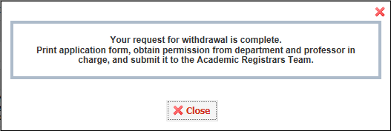

(2) Detailed information
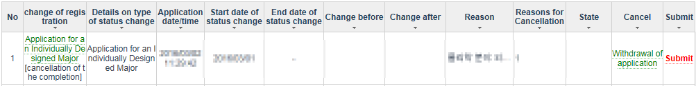
- By clicking the Status Change Type link, you can search for and view details of such application and the approval progress status of the application for the registration status change.

(3) Withdrawing the application
- Click the Withdraw Application link to withdraw the application for cancellation.

(4) Submission
- After completion of approval by the professors and the administrative department, you must submit the application through the system.

[Canceling the Completion of Application for a Minor]
(1) Application
- You can view the details of the registration status change only when there are application details of the minor applied for. Click the Cancel Completion link of the details you want to cancel.
- After entering the reason(s) for canceling it, click the Apply button to complete the application for cancellation of the completion.
- Click the Apply for Cancellation (Save) button [marked with No. 3] to complete the application for cancellation thereof.

(2) Detailed information
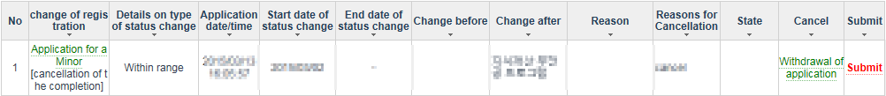
- By clicking the Status Change Type link, you can search for and view details of such application and the approval progress status of the application for the registration status change.

(3) Withdrawing the application
- Click the Withdraw Application link to withdraw the application for cancellation.

(4) Submission
- After completion of approval by the professors and the administrative department, you must submit the application through the system.

[Canceling the Completion of Application for a Double Major]
(1) Application
- You can view the details of the registration status change only when there are application details of the double major applied for. Click the Cancel Completion link of the details you want to cancel. 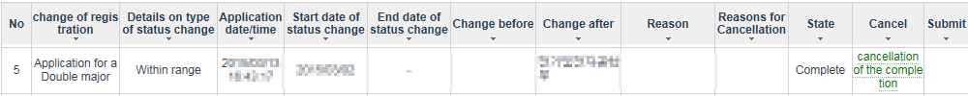
- After entering the reason(s) for canceling it, click the Apply button to complete the application for cancellation of the completion.
- Click the Apply for Cancellation (Save) button [marked with No. 3] to complete the application for cancellation thereof.

(2) Detailed information
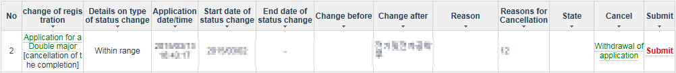
- By clicking the Status Change Type link, you can search for and view details of such application and the approval progress status of the application for the registration status change.

(3) Withdrawing the application
- Click the Withdraw Application link to withdraw the application for cancellation.

(4) Submission
- After completion of approval by the professors and the administrative department, you must submit the application through the system.

[Canceling the Completion of Application for an Interdisciplinary Major]
(1) Application
- You can view the details of the registration status change only when there are application details of the interdisciplinary major applied for. Click the Cancel Completion link of the details you want to cancel.
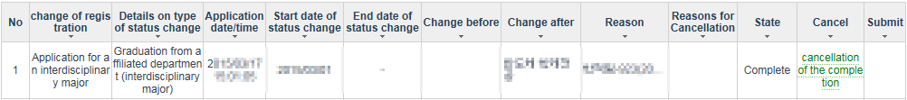
- After entering the reason(s) for canceling it, click the Apply button to complete the application for cancellation of the completion.
- Click the Apply for Cancellation (Save) button [marked with No. 3] to complete the application for cancellation thereof.

(2) Detailed information
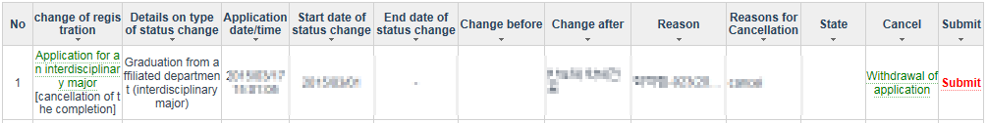
- By clicking the Status Change Type link, you can search for and view details of such application and the approval progress status of the application for the registration status change.

(3) Withdrawing the application
- Click the Withdraw Application link to withdraw the application for cancellation.

(4) Submission
- After completion of approval by the professors and the administrative department, you must submit the application through the system.

[Canceling the Completion of Application for a Coursework Master’s Degree]
(1) Application
- You can view the details of the registration status change only when there are application details of the coursework master’s degree applied for. Click the Cancel Completion link of the details you want to cancel.
- After entering the reason(s) for canceling it, click the Apply button to complete the application for cancellation of the completion.
- Click the Apply for Cancellation (Save) button [marked with No. 3] to complete the application for cancellation thereof.

(2) Detailed information
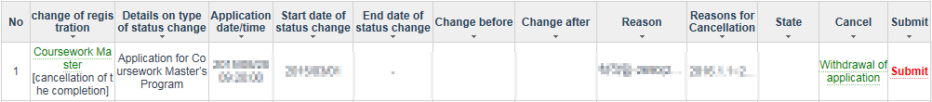
- By clicking the Status Change Type link, you can search for and view details of such application and the approval progress status of the application for the registration status change.

(3) Withdrawing the application
- Click the Withdraw Application link to withdraw the application for cancellation.

(4) Submission
- After completion of approval by the professors and the administrative department, you must submit the application through the system. In addition, you must print out the application and have it confirmed by the person in charge.

Created with the Personal Edition of HelpNDoc: Full featured EPub generator

Apply School Records Change
1. Menu
Academic Records > Apply School Records Change

2. authority
- All students

3. Display and Explanation
[List of Academic Records Change - Name]
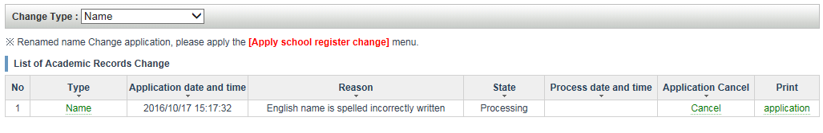
[List of Academic Records Change - Sponsor/Householder]
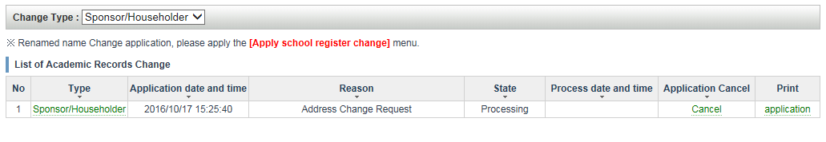
1. Search conditions: When you are selecting, the details for your selection will be provided.
2. Type: When you are click of link, display the details and update is possible.
3. Application Cancel: If you click 'Cancel' to cancel the application history.
4. Print: If you click the 'application' link, the application form can be output.
5. State
- Processing: Unapproved
- Complete: Final approval is completed.
- Cancel: The cancellation processing status

[New and Update-Name]
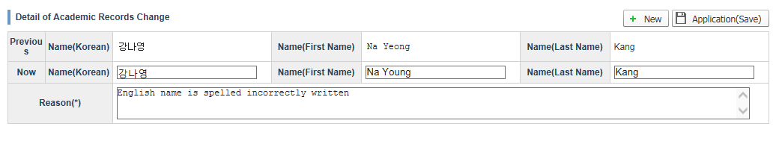
[New and Update-Sponsor/Hourseholder]
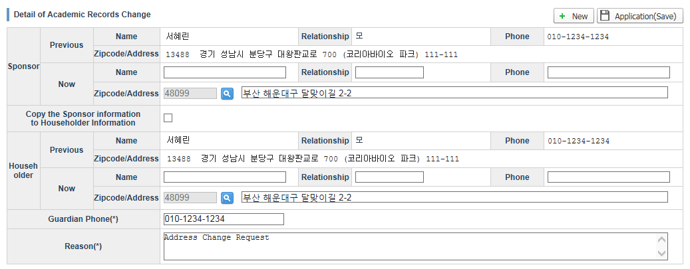
1. If you click [New], a window will be activated where you can enter details on your requested change.
2. Click ’Application(Save)‘ and your application is complete.
2. If you have changed the information you wished to modify and then click ‘Application(Save)’, the information in your application will be changed.

[Application Cancel]
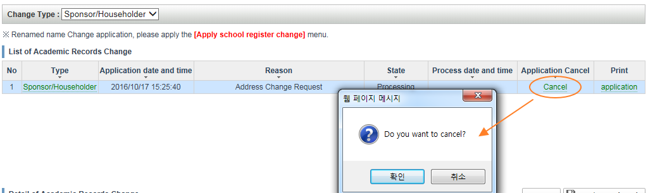

1. Click ’Cancel‘ and your Cancel application is complete.

[Application Print]
1. Click 'application' and You can print out the application form.
Created with the Personal Edition of HelpNDoc: Create iPhone web-based documentation

Menstrual Leave Requests
1. Purpose and Background of Menstrual Leave Request
The purpose of the approved leave request is for female undergraduate students to submit a request via the academic system to be excused from class due to menstrual pain for up to one day per month, once per course per month, and four times per course per semester.
※ One-year trial beginning in fall 2018

2. Menu
Class Enrolment > Menstrual Leave Request

3. Authority
- Female students in an undergraduate program

4. Screen and Description

[For non-authorized users]
The message below will be displayed to students who are not female undergraduate students.
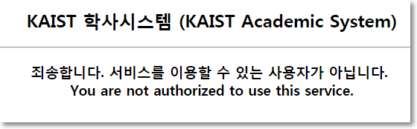

[Initial Screen]
Click the menu, and read the instructions below before clicking “OK.”
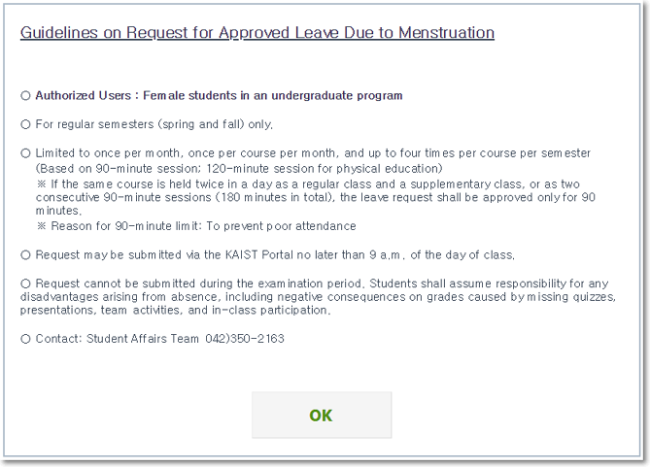

[View Request]
1. Menstrual leave requests for the current academic semester and year shall be displayed.
2. Click the link in “Date Requested” to view course details at the bottom of the screen.
The link will not be active if the date of Menstrual leave has passed.
3. The course list for the current semester shall be displayed at the bottom of the screen.

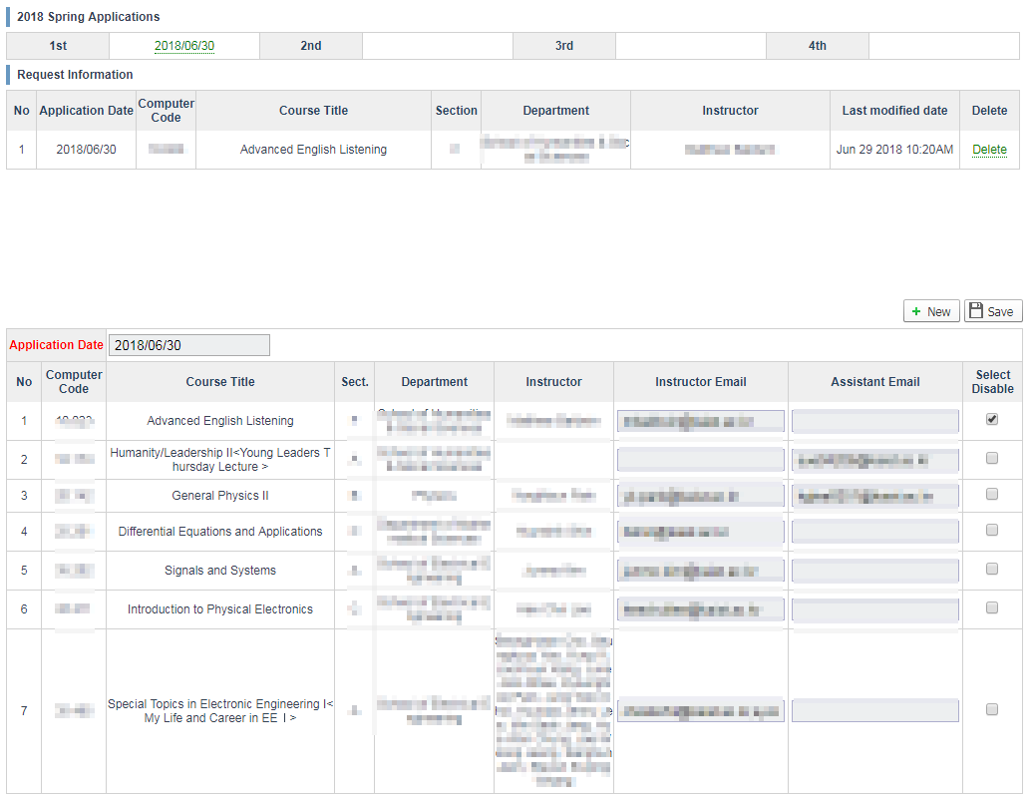

[New Request and Modification ]

1. Click the “New” button and enter the required information before clicking “Save.”
A confirmation e-mail will be sent to the instructor and teaching assistant.
2. To modify, click the link in “Date Menstrual leave Requested” and make the necessary changes before clicking “Save.”
3. Date of leave, instructor’s e-mail, and teaching assistant’s e-mail are required fields.

[Delete]

1. Click the “Delete” link to cancel your leave request for a course to which a request was submitted.
The link will not be active if the date of Menstrual leave has passed.

End.
Created with the Personal Edition of HelpNDoc: Free CHM Help documentation generator

Course Registration(Exeptions)
1. Purpose and Background of Course Registration(Exceptions)
The purpose of Course Registration(Exceptions) is to get approval from course professors through the academic system for the courses
that cannot be registered or canceled by student due to exceeding quota, third-time retake, exceeding maximum credits allowed per semester, etc.

2. Menu
Academic system > Class Enrolment > Course Registration(Exceptions)
3. Authority
- Students in state of enrollment, leave of absence, before entrance

4. Display

[If not eligible for application]

If you are not a student in state of enrollment, leave of absence or before entrance, following message will be displayed at the screen when you click the menu for application.
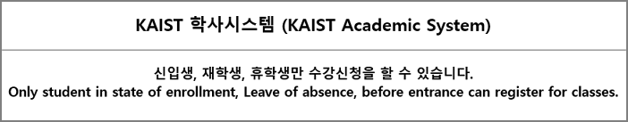

[Look up for courses]

Look up for the courses to add/drop by the condition of department, course level, course type, Kor/Eng, course code, course number, course title, instructor etc.
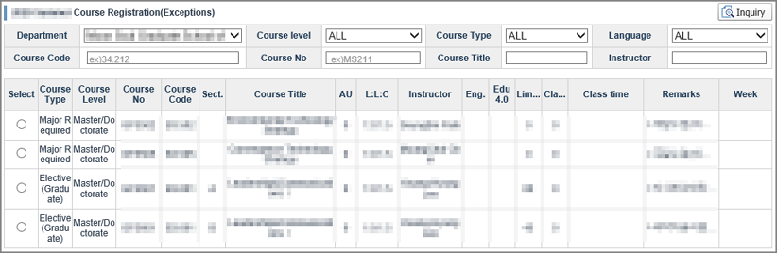

[Application for Course Registration(Exceptions)]

1. Select the course you wish apply for approval to add/drop from the courses you searched.
2. Select the [Application type].
3. Select the [Reason for Application].
4. Enter the information required for the application in [Other Information].
5. Click the [Confirm Request] button.
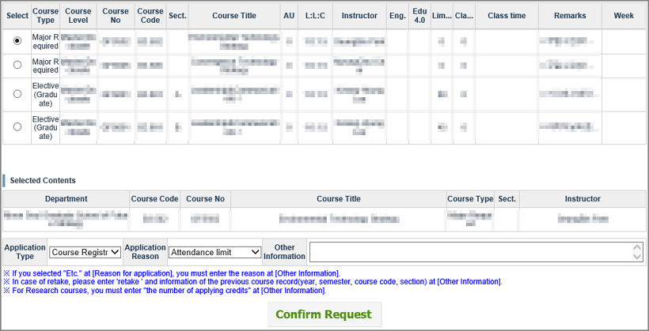

[View Course Registration Approval Requested Course]

1. At the bottom of the screen, the list of the courses that have been requested for approval is displayed.
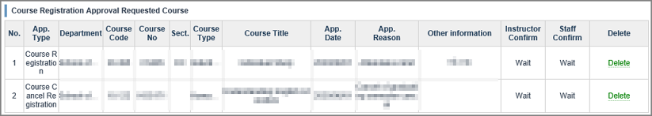

[Cancellation of Course Registration Approval Requested Course]

1. If you click the "Delete" link for each course at the list of Course Registration Approval Requested Course, the approval application for that course will be canceled.
The "Delete" link will not be active if all approvals have been completed.

문서 끝.

Created with the Personal Edition of HelpNDoc: Full featured Documentation generator

